SEUIC
User Manual

AUTOID® UF3 Demo Software

User Manual

Version 1.0

Content
Chapter 1 Parameters Setting 1
1．Connect the Reader 1
2．Reader Parameters Setting 1
Chapter 2 Parameters Setting for Working Mode 3
1．Real Time Querying mode Parameters Setting 3
Chapter 3 Necessary Background Knowledge 4
1．EPCC1G2 Tags Memory 5
2. 18000-6B Tags 5
3. Code display (EPC, UID, Password and memory are displayed in hex system) 5
Chapter 4 EPCC1-G2 Tags Testing 5
1． Query Tag EPC (response mode) 5
2．Read data and Block erase 6
3．Change password 9
4．Write EPC number 9
4.1 Broadcast writing EPC. 9
5． Lock operation 10
6．Read protection 10
7．EAS Alarming 11
8．Kill the tag (Permanently Kill) 12
9．Mask 13
Chapter 5 Buffer Operating 14
Chapter 6 Real Time Query Mode 15
Chapter 7 18000-6B Label Testing 16
1．Search tag 16
2．Data read and write/bytes write protection 16
Chapter 8 TCPIP Configuration 17
1．Web page configuration 17

Chapter 1 Parameters Setting

1．Connect the Reader
Please connect the Reader with Serial port (or Ethernet), antenna must be connected correctly before connecting to power supply.
Before connecting the device, please select the connecting type:
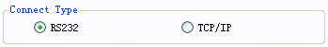
- RS232:
Reader broadcast address FF is the default address for this Demo software.
  - Select the serial port:
  - Select the baud rate
  - Click and the status bar will show as below in case of successfully accessing the reader:
- TCP/IP:
  - Input the device IP address:
  - Input the port number:
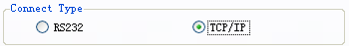
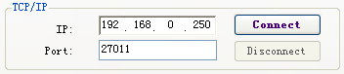
Click and the status bar swill show as below in case of successfully activating the Demo:

2．Reader Parameters Setting
1) In the text box below, please set the new reader address. It cannot be 0xFF, otherwise it will return to error.
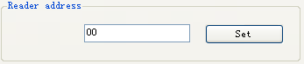
2) Set and save the output power in the drop-down box below:
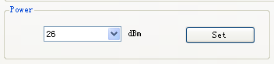
3) Select the working frequency band, channel and frequency as shown below:
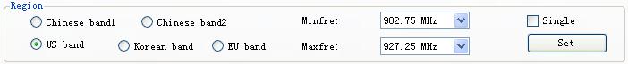
Set the minimum and maximum working frequency for the reader. The frequency differs from different region, please set the frequency within the high sensitive frequency range for tag reading. For single frequency operation, set the two frequencies the same, for frequency hopping operation, set them different in accordingly.

4) Set the baud rate for the reader, default as 57600bps. Reader power on, reader baud rate default is 57600. After change the baud rate, reader use the new baud rate until power off. Close port and open port, the baud rate no change. The demo software will use the new baud rate, until close the demo software.
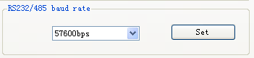
5) Select Antenna 1 and click setting to activate it, and multiple choices means multiple antenna working in the same time.
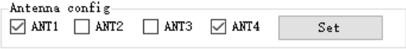
- Set Antenna Detection to confirm whether to do antenna detecting before query.
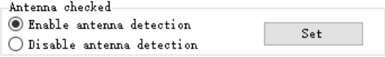
7) To set the release time in the below relay control interface, click Setting to change it.

8) Select the corresponding output port and click set to confirm notifying the output ports.
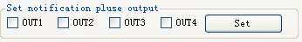
9) To set the Beep as activated or disabled in the interface below, with the Beep on, there will be sound notification for successfully processing the tags.
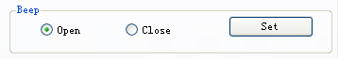
10) Click  to read the device serial number.

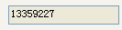。
11) Click the button below to load the factory default setting for the reader.

12) Click the below button to check the basic reader parameters information.

13) Set DRM Off for intense reading workload for large about of labels and tags.
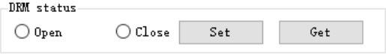
14) Click button to get the temperature of reader.
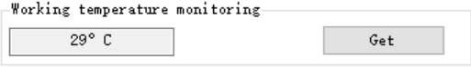
15) In the below interface meter the specific antenna port return loss.
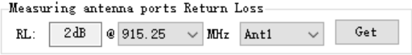

Chapter 2 Parameters Setting for Working Mode

1．Real Time Querying mode Parameters Setting
1) Set the protocol type for auto-real-time querying mode as shown below:
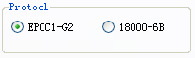
Set the Pulse interval time for auto-real-time querying mode as shown below:
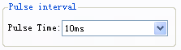
When the Pulse interval tag filter time is set to 0, it the reader will not filter any tag
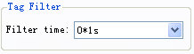
Set the Q value and Session for auto-real-time querying mode as shown below, when the Session is set to AUTO, it’s only applicable to EPC.
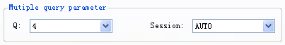
Under auto-real-time querying mode, set the mask code in the interface below, click the enable checkbox to enable or disable the mask function.
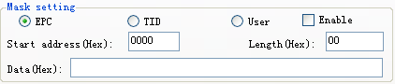
Under auto-real-time querying mode, set the TID parameters in the interface below, click the enable checkbox to enable or disable this function.
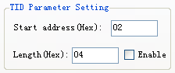
Click the below button to set parameters for selected mode.

Click the below button to check the working parameters.

2) In the below interface to select the working mode,.
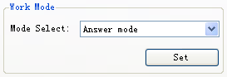

Chapter 3 Necessary Background Knowledge

1．EPCC1G2 Tags Memory
The tag memory can be classified into four storage areas logically, every memory block consists of one or more than one memory words, as defined below:
EPC: Store the area of EPC number, this module stipulates it can store 15 words EPC number. Readable and writable.
TID: Store ID number established by the tag production firm. There are 4 words and 8 words two kinds of ID numbers at present. Readable only.
User: This area of different manufacturers is different. There is no user area in G2 tag of Impinj Company. There are 28 words in Philips Company. Readable and writable.
Password: The first two characters are password for killing, and two behind are for accessing. It’s readable and writable.
All four storage areas can be set with protection. Set write-protect means the block can never be written into or cannot be written into in unsafe conditions. Set read-protect is only feasible for password protected area.

2. 18000-6B Tags
There is only one store area for 6B tag, and minimum 8 bytes as the tags UID which cannot be edited. Except the 8 bytes, the others are all editable and can be locked. Once be locked, it cannot be edited or unlocked any more.

3. Code display (EPC, UID, Password and memory are displayed in hex system)
Take the above displayed code as example, it’s specified as in hex system, so “11” is the first byte, “22” consists the second byte, and 1122 as the first word.
The above displayed code has 8 bytes, or 4 words in total.

Chapter 4 EPCC1-G2 Tags Testing

1． Query Tag EPC (response mode)
(1) Select TID/EPC to start the tag Query, take EPC for example:

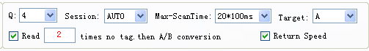
If the Session is not AUTO, the search antenna can be specified.

Note:
- Regarding the setting for Q value and Session, for single tag or limited number of tags, please set to S0, for large amount please set to S1, S2 or S3 in accordingly. The Q value is highly related to the tags, the 2 to Q power should be as many as the total number of the tags as possible. If Session is set to AUTO, please search with the preset antenna and the maximum Query time. If the return rate is set, after the Query session, it will return to the rate package.
- Quick ID search only supports part of Impinj Monza type tags as well as reading EPC and TID.
(2) Start Query

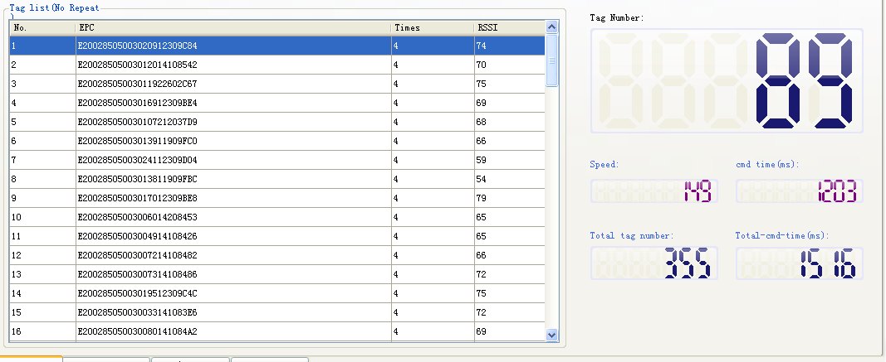
(3) Mixed Query
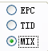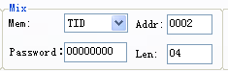
For example, the above setting means Query the TID from the second character with length of 4 words in total, click to start as shown below:
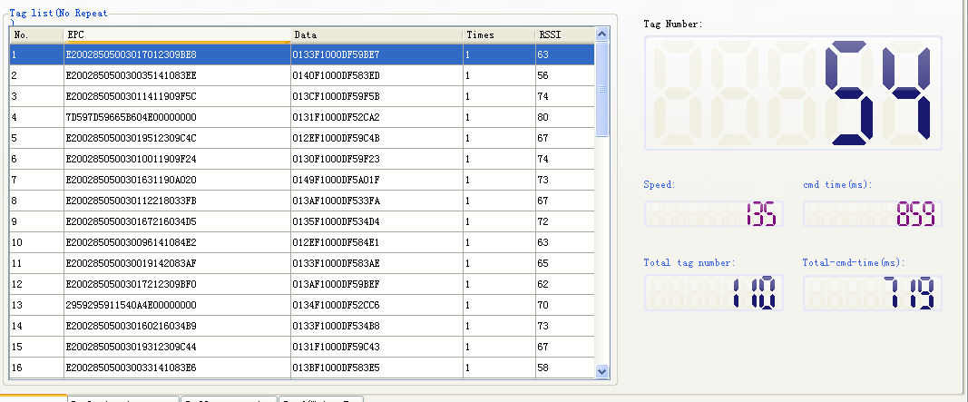

2．Read data and Block erase
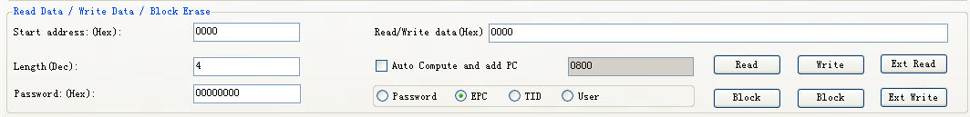
- In the drop down list, select a tag and click select, the checkbox on the left will be ticked as shown below to finish the selecting:
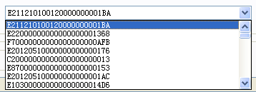，
- Select User area

（1）Procedure of reading
<1> Fill out the filter terms
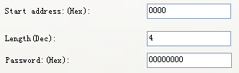
The Starting Address: 0x00 means reading start from the first word (the 16th bytes in memory area), 0x01 means from the second word, etc.
Reading length: The total number of words to be read, it can neither be 0x00 nor more than 120 words, otherwise, the reader will return error code.
Password: High-order to Low-order from left to right, for password of 2 words, the high-order will be the first word. Without password, it will default as all 0 for all the words.
<2> Click Read to read the codes, the left bottom will show success reading notification and the code displayed in the data box as show below:

（2）Write data
<1> Input the Starting Ad
dress as shown below:
<2> Input password:
Password: High-order to Low-order from left to right, for password of 2 words, the high-order will be the first word. Without password, it will default as any random password as the same length.
<3>Input data what you want to write like
<4> Click Write for the success written notification at the left bottom as show below:

（3）Block writing operating procedure
<1> Input the Starting Address and password as shown below:
Input data you want to write:
Password: High-order to Low-order from left to right, for password of 2 words, the high-order will be the first word. Without password, it will default as any random password as the same length.

<2> Click Bock write button ,for the success written notification as show below:

（4）Block erase operating procedure( to erase the selected data to 0)
<3> Input address and passoword:
The Starting Address: 0x00 means reading start from the first word (the 16th bytes in memory area), 0x01 means from the second word, etc.
Erase length: The total number of words to be erased, it can neither be 0x00 nor more than 120 words, otherwise, the reader will return error code..
Password: High-order to Low-order from left to right, for password of 2 words, the high-order will be the first word. Without password, it will default as all 0 for all the words.
<4> Click Bock erase button,


3．Change password
（1）Select the tags as shown
（2）Select the memory area:
（3）Input the access password
Access password: default is 00000000, if you have changed it to others, you should input right values.
Click Write to confirm.
（4）Change the destruction password to 12345678 as shown:
Click Write button

4．Write EPC number

4.1 Broadcast writing EPC.
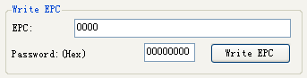
- Input access password (if the EPC area is not protected with password, please input any 8 numbers)
- Click to write, during which time, the antenna is only effective for one tag. It means, even though there are multiple tags with same access password or no password at all, click once to write EPC can only change one EPC randomly.

5． Lock operation
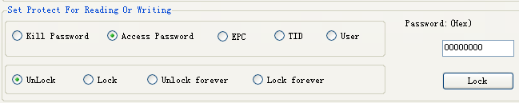
（1）Select the tag
（2）Select the area
（3）Select the type
（4）Input the access password and click  . Please check the notification to make sure the operating has taken effect(password cannot be zero).

6．Read protection
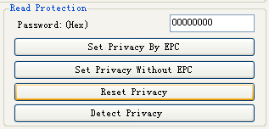
<1> Select the tag
<2> Input the access password ( if the password is 0, please change the password at first)

（1）Single tag read protection
Click the below button to set read protection to the selected tag, the tag cannot be read, write or query . It’s only effective for NXP UCODE EPC G2X tag.

（2）Single tag read protection (Without EPC)
Click the below button to set single tag read protection (Without EPC) for specific range of tags.
The difference from is that when there are several tag in the effective range of antenna, reader cannot know which tag is operated. .
If you are to do this operation on several tags, please make sure every tag has the same password. It only effective for NXP UCODE EPC G2X tags.
（3）Reset Single Tag Read Protection without EPC
Click the below button to unlock the read protection. The antenna is only effective for one tag and support NXP UCODE EPC G2X tag only.
Note: For tags this function doesn’t support will be unprotected as default.
（4）Detect single protected tag( without Query or accessing)
Click the below button to detect whether the tag is protected. For tags this function doesn’t support will be unprotected as default. Make sure that there is single tag in the effective range of antenna. Only NXP UCODE EPC G2X tags valid.

7．EAS Alarming
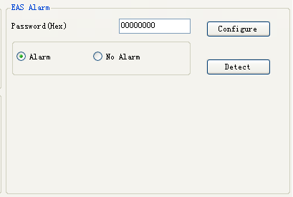
（1）Alarming setting
<1> Select the tag
<2> Input access password (if the EPC is not password protected, please input any 8 numbers)
<3> Select Alarming to set or reset the EAS status.
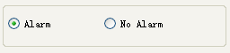
It supports NXP UCODE EPC G2X tag only.
（2）Detect Alarming (without Query or accessing)
<1> Click detect Alarming as below to activate the Alarming:
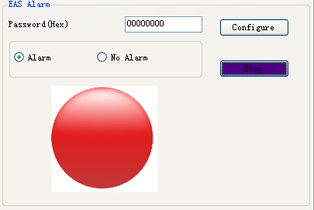
It supports NXP UCODE EPC G2X tag only.
<2> Detect with Alarming will show as below:
Detect no EAS Alarming as shown below:

8．Kill the tag (Permanently Kill)

（1）Select the tag
（2）Input access password (if the EPC is not password protected, please input any random 8 numbers)
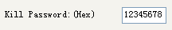
After being killed, the tag will not react to any orders from the processor. To Kill the tag, the password cannot be all 0, otherwise the reader will return error code.

9．Mask

（1）Select Enable the function
Select Enable to activate and start the operation.
Take EPC for example:
For Mask area, please select EPC as shown below:
Change the Starting Address for Mask data as shown below:
Set the Mask data length:
Set Mask data:
Only the tag with first byte as DA will response.
TID mask:
<1> Query the TID of tags
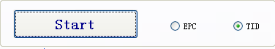
<Set the Mask code filter>
Take changing EPC for example as shown below:
<2> Select EPC area as shown, the starting bytes for EPC will be fixed as 2.


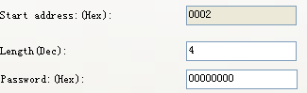
<3> Input the access code and the EPC data to be changed into.
<4> Click Write to see the prompted success writing notification at the left bottom to confirm changing the tag EPC via TID successfully.

Chapter 5 Buffer Operating

- Select TID/EPC Query, take EPC for example, the Q value is default as 4 , Session as 1, and Target as A, to read the Bufferd total number of tags if there is any.

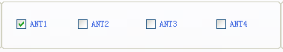
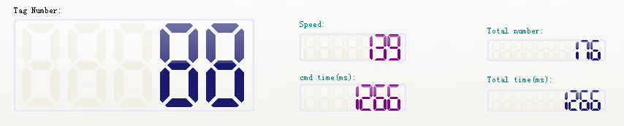
（2）Click read the Buffer to get the tag information in the Buffer as shown below:

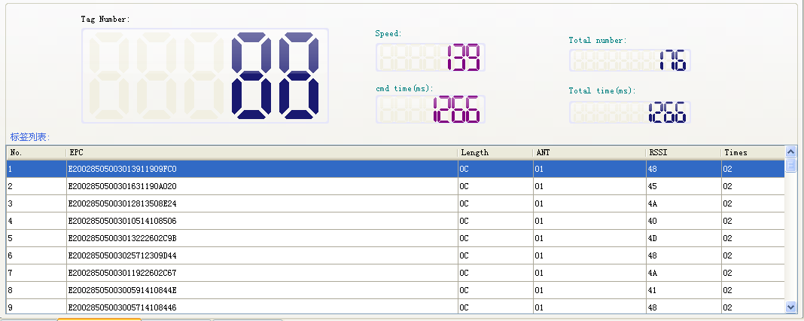
- Click Clear Buffer to delete all the Bufferd tags information.

- Click to Read and clear the Buffer

（5）Click to check the Buffered tags total number as shown below


Chapter 6 Real Time Query Mode

- Select Real time auto Query Mode in the working mode selection and click to confirm.
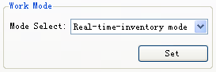
- Then click Start Query to get the searched data.
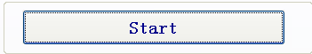
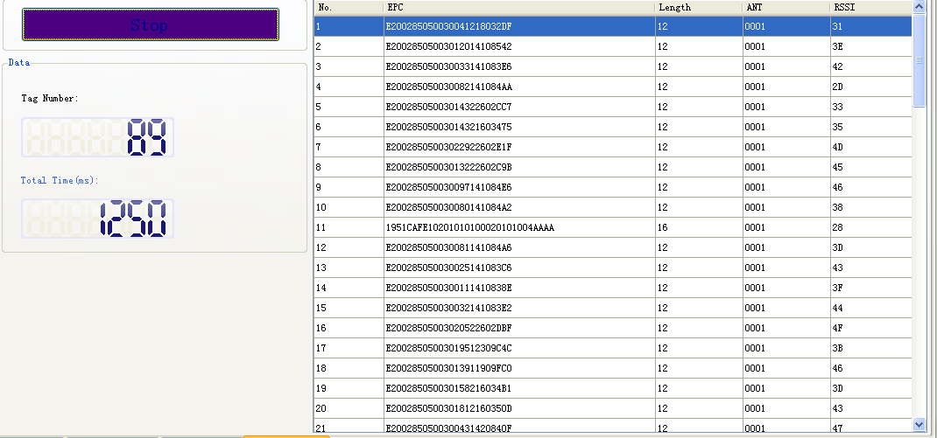

Chapter 7 18000-6B Label Testing

1．Search tag

The above set Single Querying mode is only useful for Query of single tag, in case of multiple tags under the same antenna range, no tag can be searched.

2．Data read and write/bytes write protection
In the tag list, select one and double click to see the display of the tag as shown below:
- Set the reading range
The Starting Address: 0x00 means reading start from the first word (the 16th bytes in memory area), 0x01 means from the second word, etc. within the range of 0 to 223. Otherwise the reader will return error code.
Read length: The total number of words to be read should be within 1 to 32, in case of reading start point plus read length is more than 224, or read length bigger than 32 or equal to 0, the reader will return error code.
（3）Set the Writing length
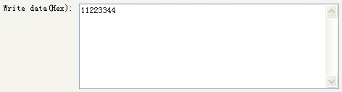
Write data: The length is limited within 32 bytes, in case of writing length being 0 or over 32, or the Starting Address plus the length is more than 224, the reader will return error code.
（4）Permanent writing protection means lock the specific bytes.

- Detect permanent writing protection status means to confirm whether the selected bytes being locked.

Chapter 8 TCPIP Configuration

1．Web page configuration
1.) Click Operate button and then Search in Operation menu.
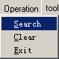
Detect the connected device to click as shown below:
2.) Select IE for the prompted log-on interface, the default user name and password are admin, then click to log on the configuration interface as shown below.
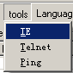
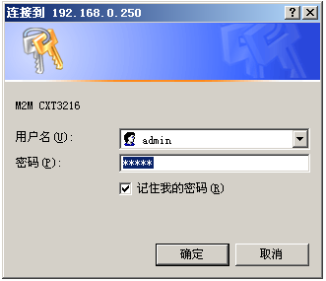
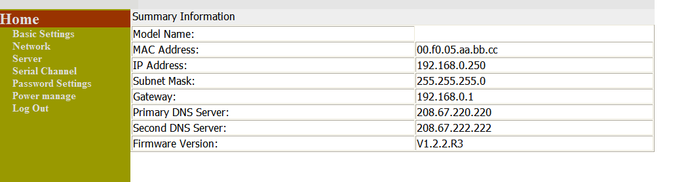
(1) Select Network to configure the reader IP address, and click submit to confirm.
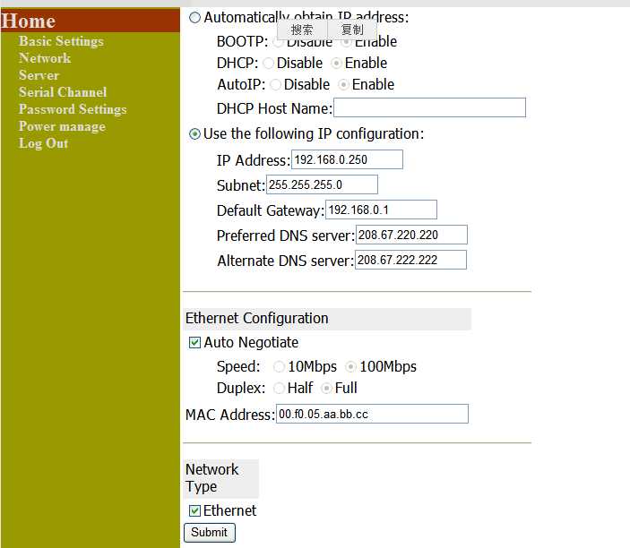
- Select Serial Channel to configure the serial ports, the default setting is shown as below:
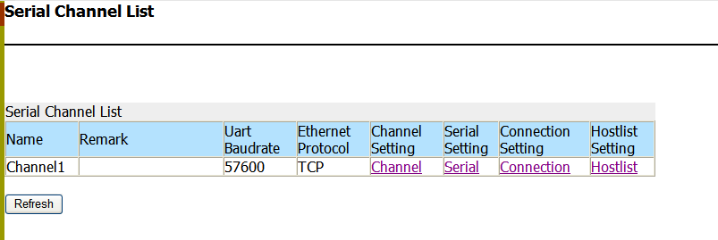

Click to do the setting as below and click Submit to confirm.
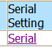
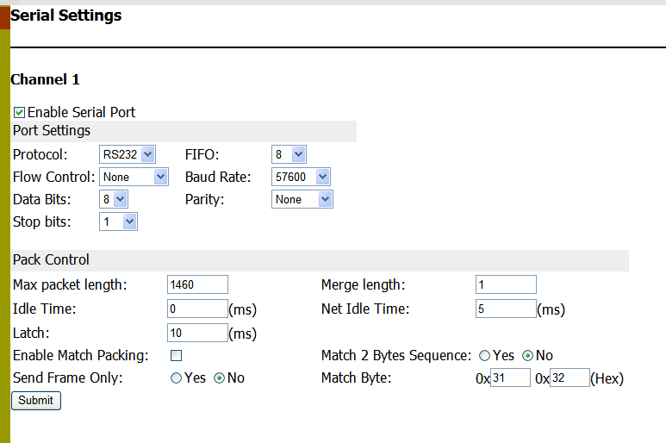
The default baud rate is 57600, please note that the baud rate should be kept the same as the reader baud rate.

Click Connection to configure the Connection setting as shown below:
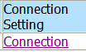
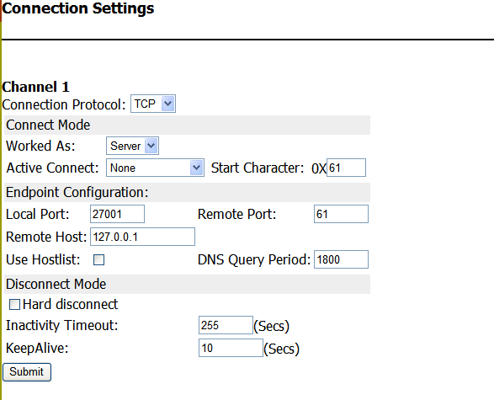
If the Reader is worked as server, please use Local Port as the access port,.
If the Reader is worked as terminal, please use server port and the server IP address for Remote Port.
- Please click Power manage to finish all the configuration and reset the device as shown below.
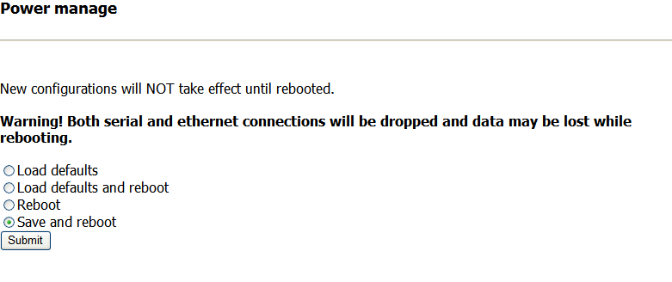Click Submit to complete the configuration.

