东集
EUIC
S
Android UHF Interface
User Manual

www.seuic.com
Revising index
Version | Update date | Revising details | By
1.0 | 9/1/2016 | Create the Chinese version | Xiaodong Feng
1.1 | 1/2/2019 | Increase the number of blockwrite and blockerase interfaces | Xiaodong Feng

Content
Abstract 3rd
Hardware platform 3rd
Software platform 3rd
Object oriented 3rd
Quote method 3rd
UHF Interface 4th
UHFService class 4th
Using method 4th
Function interface 4th
1. Switch UHF on 5th
2. Switch UHF off 5th
3. Get the firmware version number 5th
4. Get the temperature 5th
5. Get the power 5th
6. Set the power 6th
7. Get field 6th
8. Set field 6th
9. Singe tag reading 6th
10. Start continuous tag reading 6th
11. Stop start tag reading 7th
12. Get the quantity of the continuous tags reading 7th
13. Get the continuous tag reading ID 7th
14. Read the label 7th
15. Write the label 8th
16. Block write the label 8th
17. Block erase the label 8th
EPC class 9th
Class member variable 9th
Using method 9th
Function interface 9th
1. Get the ID data from EPC oriented object 9th
2. Match the ID number 9th

Abstract
This document is created to provide the users the manual for the interface related to D500 device, to help them better use the special functions of the terminal product.

Hardware platform
SDK is applicable to the devices listed below：
- D500

Without further limits definition in functional interface instruction, its using range shall be redeemed as applicable to all.

Software platform
SDK is based on Android 4.4, and it supports the eclipse development tool.

Object oriented
It’s designed for the developers who would like to use UHF module besides the Android standard functions.

Quote method
- Take Eclipse for example, right click Program, then Properties, Java Build Path, Libraries, Add External JARs, select uhf.jar.
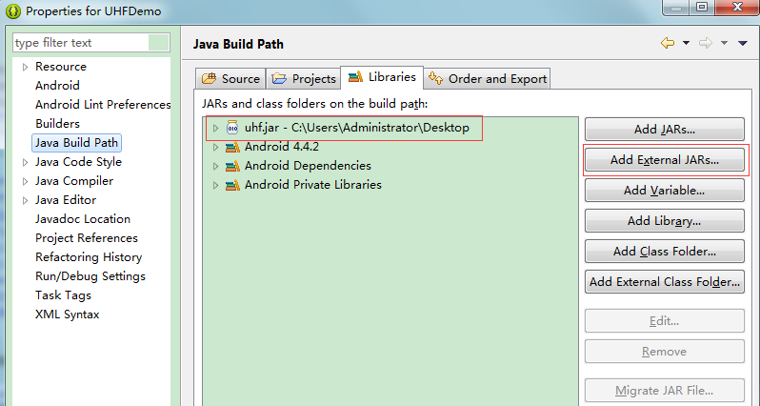

- AndroidManifest.xml uses uses-library to ID the uhf.jar is quoted package.
<application
……
<uses-library
android:name="com.seuic.uhf" />
……
</application>

UHF Interface
Package name | com.seuic.uhf
Package file | uhf.jar
System package | Yes
Class | UHFService
Function | Provide the control interface related to UHF

UHFService class

Using method
import com.seuic.uhf.UHFService;
UHFService mDevice = UHFService.getInstance();

Function interface
Function | Specification
open | Switch UHF on
close | Switch UHF off
getFirmwareVersion | Get the firmware version number
getTemperature | Get the temperature
getPower | Get the power
setPower | Set the power
getRegion | Get field
setRegion | Set field
inventoryOnce | Singe tag reading
inventoryStart | Start continuous tag reading
inventoryStop | Stop continuous tag reading
getTagIDCount | Get the quantity of the continuous tags reading
getTagIDs | Get the continuous tag reading ID
readTagData | Read the label
writeTagData | Write the label
blockWriteTagData | Block write the label
blockEraseTagData | Block erase the label

- Switch UHF on
boolean open ()
Parameters
non
Return value
boolean; true for success and false for failure

- Switch UHF off
void close ()
Parameters
Non
Return value
non

- Get the firmware version number
String getFirmwareVersion ()
Parameters
non
Return value
String: not null for success and null for failure

- Get the temperature
String getTemperature ()
Parameters
non
Return value
String: not null for success and null for failure (℃)

- Get the power
int getPower ()
Parameters
non
Return value
int; not-o for success and 0 for failure (0~30 dBm)

- Set the power
boolean setPower (int power)
Parameters
power
Set the power as (0~30 dBm)
Return value
boolean; true for success and false for failure

- Get field
String getRegion ()
Parameters
non
Return value
String; non blank for success and null for failure
Range value including：”FCC” , ”ETSI”, ”China1” , ”China2”

- Set field
boolean setRegion (String region)
Parameters
region
Range value including：”FCC” , ”ETSI”, ”China1” , ”China2”
Return value
boolean; true for success and false for failure

- Singe tag reading
boolean inventoryOnce(EPC epc, int timeout)
Parameters
epc
EPC class oriented object
timeout
Order time out (0~500 ms)
Return value
boolean; true for success and false for failure

- Start continuous tag reading
boolean inventoryStart ()
Parameters
non
Return value
boolean; true for success and false for failure

- Stop start tag reading
boolean inventoryStop ()
Parameters
non
Return value
boolean; true for success and false for failure

- Get the quantity of the continuous tags reading
int getTagIDCount ()
Parameters
non
Return value
int; non-0 for the quantity of the labels got, and 0 for noting getting any label

- Get the continuous tag reading ID
List<EPC> getTagIDs ()
Parameters
non
Return value
List<EPC>; The List collection of all EPC oriented objects

- Read the label
boolean readTagData (byte[] Epc, byte[] PassWord, int Bank, int Offset ,int Len, byte[] Data)
Parameters
Epc
Label ID（PC+EPC）
PassWord
Visit password (length as 4 bytes)
Bank
Label saving area(0 for password,1 for EPC, 2 for TI and 3 for users)
Offset
Starting address (unit as byte)
Len
the length to read, with unit as byte
Data
save the data to be read in the label
Return value
boolean; true for success and false for failure

- Write the label
boolean writeTagData (byte[] Epc, byte[] PassWord, int Bank, int Offset ,int Len, byte[] Data)
Parameters
Epc
Label ID（PC+EPC）
PassWord
Visit password (length as 4 bytes)
Bank
Label saving area(0 for password,1 for EPC, 2 for TI and 3 for users)
Offset
Starting address (unit as byte)
Len
the length to write, with unit as byte
Data
save the data to be written into the label
Return value
boolean; true for success and false for failure

- Block write the label
boolean blockWriteTagData (byte[] Epc, byte[] PassWord, int Bank, int Offset ,int Len, byte[] Data)
Parameters
Epc
Label ID（PC+EPC）
PassWord
Visit password (length as 4 bytes)
Bank
Label saving area(0 for password,1 for EPC, 2 for TI and 3 for users)
Offset
Starting address (unit as byte)
Len
The length to write, with unit as byte
Data
save the data to be written into the label
Return value
boolean; true for success and false for failure

- Block erase the label
boolean blockEraseTagData (byte[] Epc, byte[] PassWord, int Bank, int Offset ,int Len)
Parameters
Epc
Label ID（PC+EPC）
PassWord
Visit password (length as 4 bytes)
Bank
Label saving area(0 for password,1 for EPC, 2 for TI and 3 for users)
Offset
Starting address (unit as byte)
Len
The length to erase, with unit as byte
Return value
boolean; true for success and false for failure

EPC class

Class member variable
byte[] id;
int len;
int rssi;
int count;

Using method
import com.seuic.uhf.EPC;
EPC epc = new EPC();

Function interface
- Get the ID data from EPC oriented object
String getId()
Parameters
non
Return value
String; a hexadecimal string

- Match the ID number
boolean equals(Object obj)
Parameters
EPC oriented object
Return value
boolean; true for success and false for failure

