**STASD60 RT UHF DEMO**

**UserManual**

**ISO18000-6C**

This example is for UHF models. Only operate ISO18000-6C protocol UHF tags

Support label band:

840-845 (China)

920-925 (China)

902-928 (open band)

865-868 (Euro)

**Enable UHF trigger**

1. System Setting
2. Pikestaff
3. Enable UHF trigger

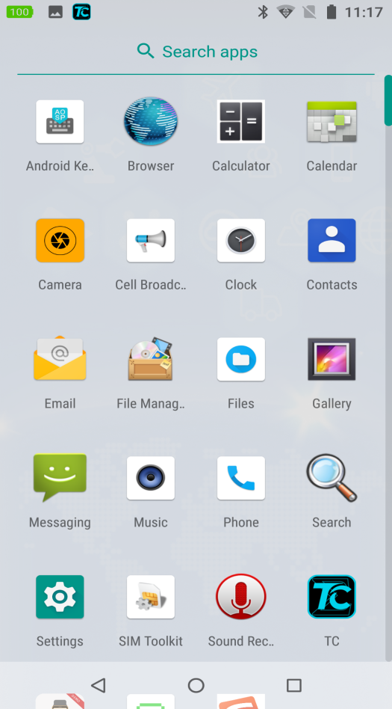

**System setting**

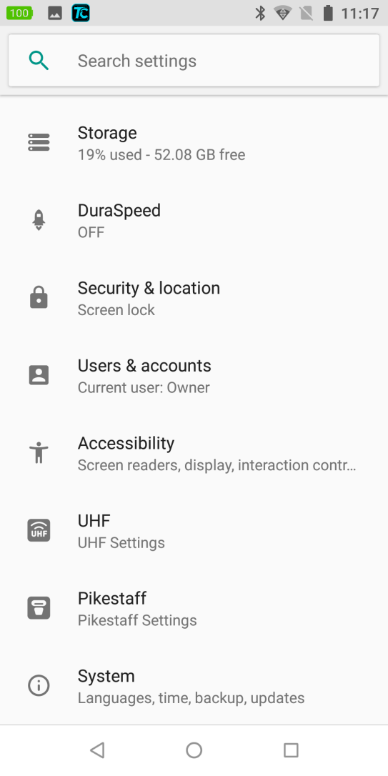

**Trigger setting**

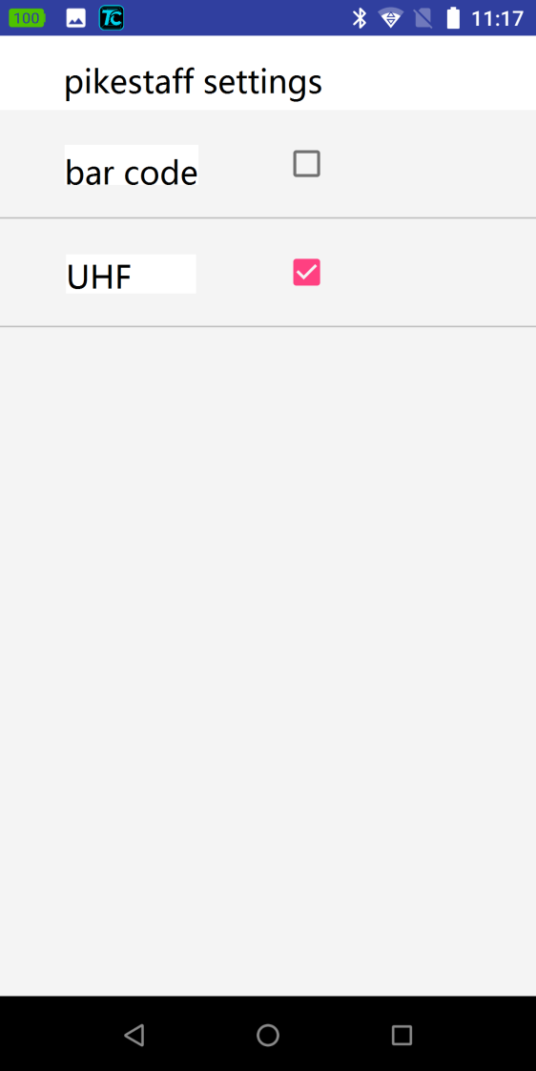

**Check mark enable UHF**

**Start UHF by trigger**

**After select UHF in pikestaff setting, user can activate the UHF processing by press the trigger instead of click start button which is very convenience way with glorious customer experience,press trigger again to stop searching.**

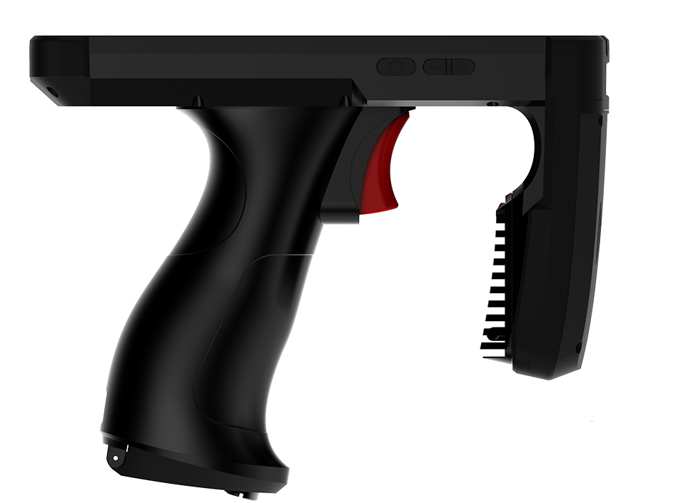

**Press red trigger to start searching**

**UHF Demo main interface**

**Input card No.to find the card**

**UHF setting**

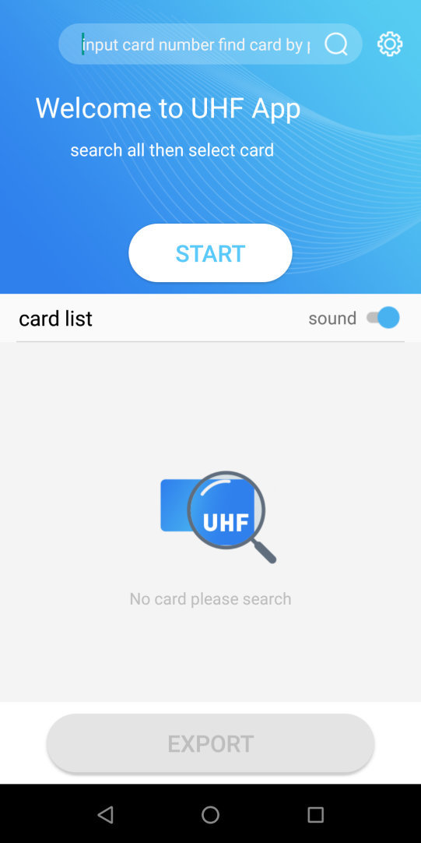

**click start or press pistol trigger to start searching all cards nearby**

**Show the card list in this area**

**Export data**

**Sound enable**

**UHF settings**

**Select the band of the tag that you need to read: 840-845(China)920-925(China)**

**902-928(open band) 865-868(Euro)**

**Set antenna power**

**Fill in power, the value is 0-30, the greater the value, the farther away from tag.**

**Back to main interface**

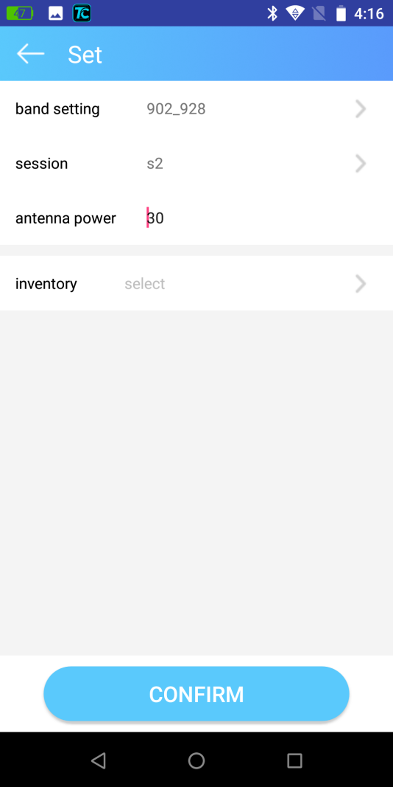

**Antenna power setting**

**Card frequency band setting**

**Inventory sector: EPC+TID EPC+USER only EPC EPC+PID**

**Confirm your setting**

**Card searching**

**The Number of card in range**

**Scanning time consumption**

**Scanning frequency**

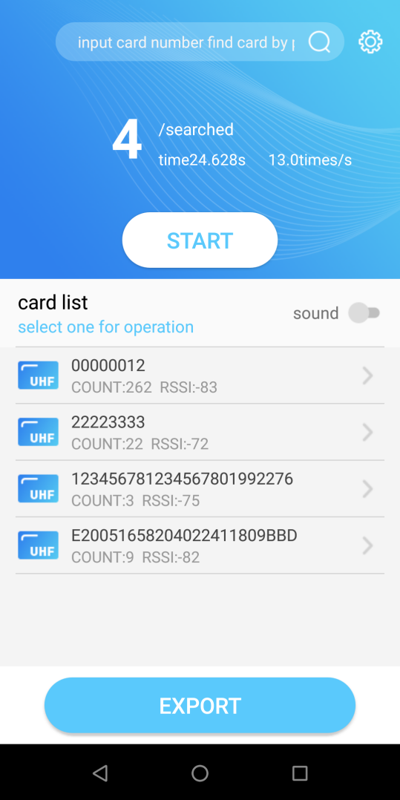

**Card information select one card to operated R/W**

**R/W Card**

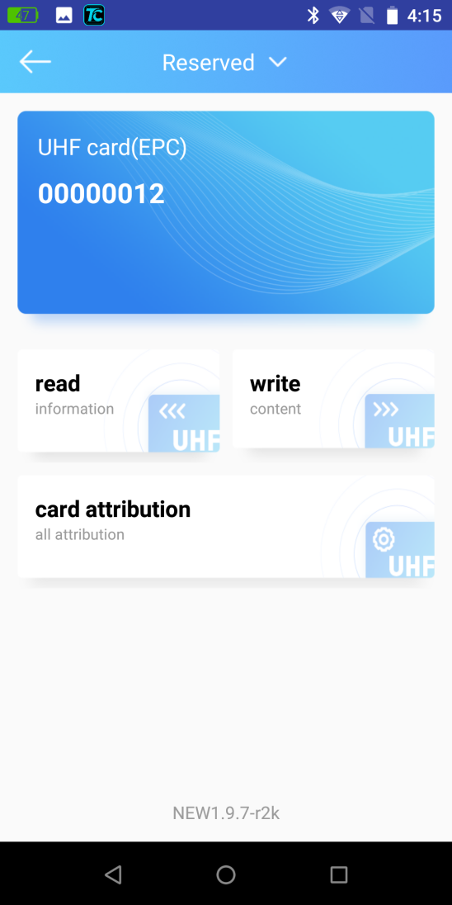

**Card attribution setting**

**Current operating card**

**Press to read card data**

**Press to write card**

**Read Card**

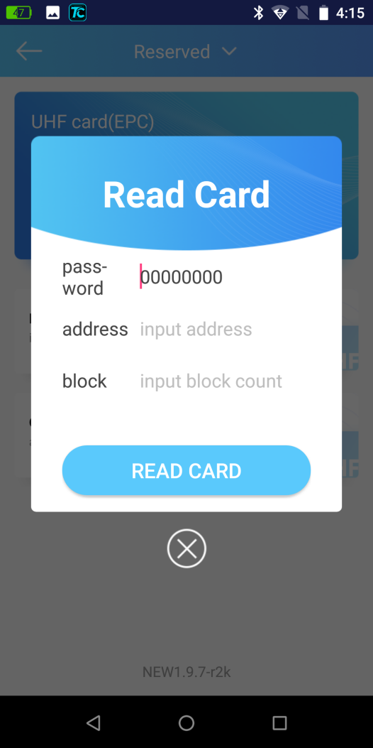

**Unlock by password**

**Default :00000000**

**Default status: unlock**

**Start address to read**

**Fill the block count (unit is word)**

**write Card**

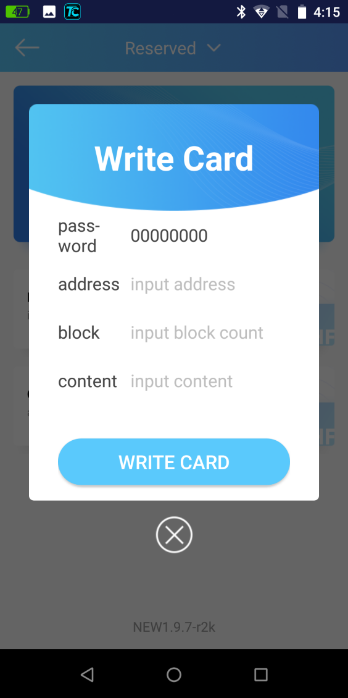

**Unlock by password**

**Default :00000000**

**Default status: unlock**

**Fill write content**

**Fill the block count (unit is word)**

**Start address**

**Card attribution setting**

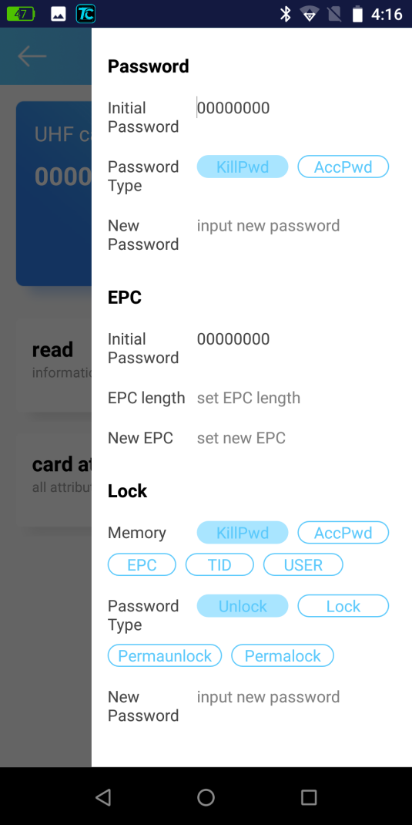

**Card attribution specification**

**Password:** for update new Pwd ,or when you forget the current Pwd, input initial password choose password type (kill/success ) then set new password

**kill password:** input kill password before kill the UHF tag.

**access password:** input access password before read/write UHF tag.

**EPC:**for operation EPC section, fill initial password for access the EPC, set EPC length (the unit by word) and create new EPC

**lock:**for lock or unlock the memory sector in UHF tags. Please set access password before this operation . after kill Pwd&Acc Pwd sector been locked ,only can be read by supply correct password but EPC TID and USER. These 3 sectors approval to write it by input access password.

**Search Card by sound**

base on the searched cards we can confirm the anyone card location by sound.

1. please notice how many cards is exist in the UHF antenna detection range.
2. Click the hint text”input card number find card by sound” in search box ,all detected cards ID will list and pop up for your selection.
3. Finally click the “zoom lens”icon to activated the search engine.

**4.click “zoom lens” to start searching**

**2.click here to input card No.**

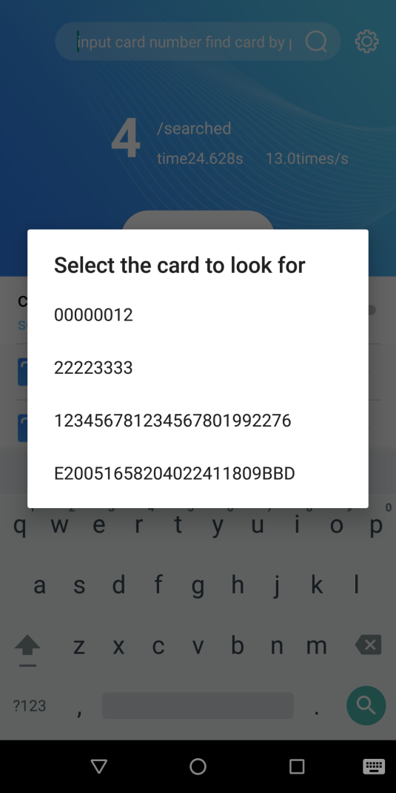

**3.Detected cards list pop up**

1. **4 cards has been found,in the detection scope**

1. press “zoom lens”go into searching interface, the nearer distance from the target card the more dense hint sound. Finally judge the card location by beeper sound density. Press “stop”to halt searching.

