Jul 01, 2013

To,

Customer name
Address

Dear Sir,

Greetings. We would like to thank you for your enquiry towards vehicle tracking application using RFID (Radio Frequency Identification) technology. As discussed, please find below the proposal for your kind perusal.

I hope you find the proposal in order and shall not hesitate to give us a chance to serve your esteemed organization.

Please feel free to contact me in case of any further clarification needed.

Thank you & best regards

Sreenesh Shenoy
Chief Technology Officer

Stallion, an ISO 9001-2000 certified company provides Barcode, RFID, EAS, BIOMETRIC, POS & SOFTWARE solutions… to clients in India and Middle East – as partners to conceptualize and realize their initiatives, to reach out their Vision. Whether it is Manufacturing, Retail, Service or Export, we ensure a level of certainty of results that no one can match. Started a decade ago Stallion thrives on professionalism, business ethics and customer delight. With over 17 branches and 300 employees spread across India and Middle East . Stallion stands out to be a leading company in Automatic Identification and Data Capturing Industry.

Stallion is the authorized distributor in India and Middle East for Datamax printers, Datalogic (formerly PSC) scanners and top manufacturers of RFID, EAS, BIOMETRIC & POS products in the world. Our manufacturing facility with sophisticated machineries in UAE , Mumbai and Kochi caters to customer’s label, ribbon and tag requirements. Our In house development center provides software solutions and well trained engineers provides technical and maintenance support.

Solutions and Services of Stallion are used by over 5000 companies to improve their business processes, increase productivity, and strengthen security. Some of our esteemed clients include Tata, Reliance, BSNL, ITC, Reebock, Ford, Toyota, TVS, HAL, Hindustan Lever, Lupin, Big Bazaar, BHEL, Lifestyle, Videocon, TNT, Max, Reid &Tailor ,Saint Gobian to name a few.

OUR VISION
To become a globally leading and reputed organization, respected by all stake holders such as Customers, Employees, Partners and Society.

OUR MISSION
To achieve profit, by providing best of products, technologies, services to its customers by practicing business ethics and to become useful to the society.

OUR QUALITY POLICY
Team Stallion is committed to give highest priority to the quality aspect in every product, service and solutions given to its customers, through continuous knowledge updation, product and process training to every team member, there by achieving customer delight.

MEMBERSHIPS

STALLION is a member of
- GSI India ( Under Commerce Ministry Govt. of India )
- CII
- AIM USA
Introduction

Radio frequency identification (RFID) is a generic term that is used to describe
a system that transmits the identity (in the form of a unique serial number)
of an object or person wirelessly in a tag, using radio waves. Tags or Transponders are micro chips with an antenna which have a unique Identifier Number and memory which can be programmable according to the customer requirement. Tags are then affixed to the Items.

Proposed Solution
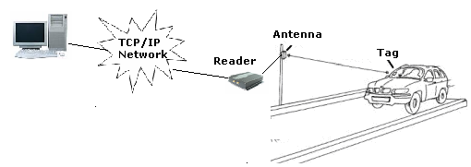

Vehicle Registration & Tagging
Every vehicle need to be registered in the RFID based vehicle tracking software. A RFID tag with a unique serial number will be programmed in the software and will be attached to the windshield of each vehicle.

Installing RFID Antenna at the Entrance/Exit Gate
A long range RFID reader connected with an external antenna will be installed at the Entrance/Exit gate of the parking ground. This reader will be connected to the server PC using the TCP/IP cable

Automatic Identification during Entrance/Exit
When a vehicle fixed with RFID card moves through the gate, the reader will automatically read the serial number of the tag. This number will be send to the server by the reader and the software running in the server will verify the serial number and the entrance/exit time will be recorded in the database.

Software can also send command to a Boom barrier to automatically open the gate. As per the command received from the software, reader will send a relay output to boom barrier for opening.

Financial Proposal

Item | Image | Description | Application | Qty | Price
STA W10040 Windshield tag | 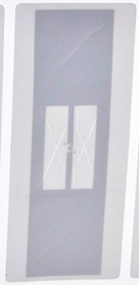 | UHF Self-destructible Windshield Tag  Material: Coated paper  Dimensions: 100×40mm(custom)  Working temperature: -40℃～70℃  Protocol: EPC C1G2 (ISO18000-6C)  Frequency: 860～960MHz  Chip: NXP G2IM  EPC memory: 256 bits  User memory: 512 bits  Read range: 6--10m（depend on reader power） | For pasting on windshield of vehicles | 1 | 26.00
STA IR0507E Middle distance reader with Relay output | 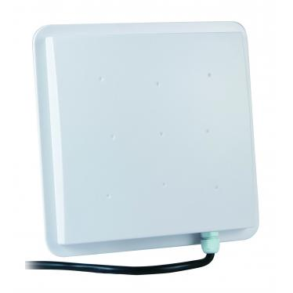 | UHF middle-distance integrative reader  Processor :ARM CORTEX M3 100M  Memory :RAM 16Kbits + FRAM 32Kbits.  Frequency：860MHz-868MHz(CE)  Protocol ：ISO18000-6B, EPC G2  Interface : RS232, RS485, TCP/IP  GPIO : 1 Relay output, 2 TTL outputs, 2 TTL inputs  Reading Range：5 - 8 m  Power Consumed：DC+9V/12V | 1 reader for 4 to 5 meter coverage,  2 readers for 5 to 10 meter coverage | 1 | 38,500.00
Vehicle Tracking Software |  | Vehicle/Owner management  RFID vehicle tag management  Vehicle permissions  Vehicle movement reports | Software | 01 | 90,000.00

Terms and Conditions
- Taxes extra as applicable
- Payment : 100% advance
- 1 year Warranty for hardware items
- Delivery: 4-5 weeks after the confirmed order
- Suitable computer and TCP/IP network for this application to be provided by customer

