**SEUIC**

**Reference Manual**

AUTOID®UF3-S 8-Channel Fixed RFID Reader

User Instructions for Android demo

Version 1.2

## Copyright Notice

The information contained in this manual is provided "as is" and is subject to change without prior notice.

SEUIC Company does not make any warranty for the contents contained in this manual, including but not limited to warranties that imply merchantability and suitability for specific purposes. SEUIC Company is not liable for the errors contained in this manual or for the accidental or incidental losses caused by the supply, execution or use of this manual or its examples.

Software copyright 2021 -2022 SEUIC Company

If you need further product information and support, please contact our sales representative or check directly on our website.

SEUIC Technologies Co., Ltd.

No.15 Xinghuo Road, High-tech Industrial Development Zone, Jiangsu Province

Post code: 210061

Tel: 86-25-52261298

Fax: 86-25-52268995

Official website of the Company: [www.Seuic.com](http://www.Seuic.com)

Official website of products: [www.ChinaAUTOID.com](http://www.Chinaautoid.com)

Service hotline: 400-677-0876

Service email address: [AUTOID@seuic.com](mailto:AUTOID@seuic.com)

* Document Release Record

|  |  |  |  |
| --- | --- | --- | --- |
| **Version No.** | **Revised content** | **Revised on** | **Revised by** |
| V1.0 | Initial version | 20220309 | Wang Mengjie |
| V1.1 | Update Copyright Notice | 20220426 | Min Qingbo |
| V1.2 | Increase antenna detection | 20220511 | Wang Mengjie |
|  |  |  |  |
|  |  |  |  |
|  |  |  |  |
|  |  |  |  |

CONTENTS

Copyright Notice 2

Chapter I Tag Inventory 5

1.1 Single card search 5

1.2 Continuous card search 6

1.3 Stop card search 7

1.4 Clear 7

Chapter II Parameter Setting 7

2.1 Set parameters 9

2.2 Get parameters 10

2.3 Restore factory settings 11

Chapter III Tag Read and Write 12

3.1 Set filter 13

3.2 Read card 14

3.3 Write card 15

3.4 Clear 16

3.5 Lock tag 16

3.6 Destroy tag 16

# Chapter I Tag Inventory

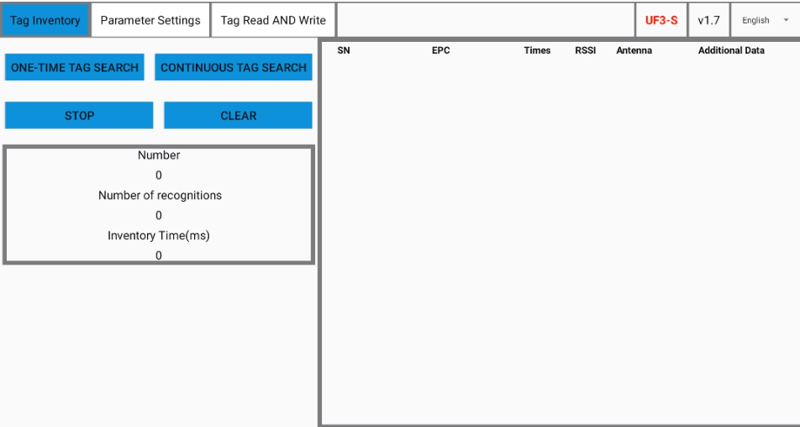

## 1.1 Single card search

* Click Single Card Search for card search once
* Tag information: EPC, inventory times of this tag, RSSI, read antenna and additional data (which shall be set in the parameter setting interface first)
* Each time a single card search is clicked, the tag list will be cleared first

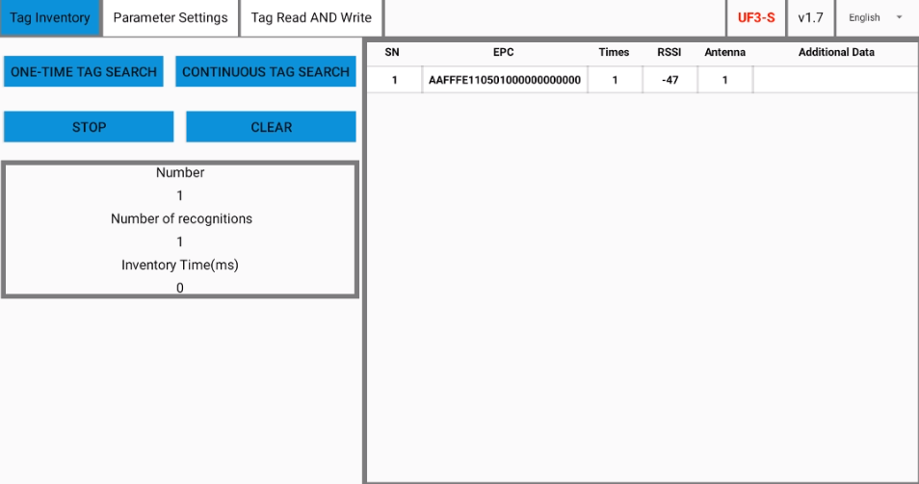

## 1.2 Continuous card search

* Click continuous card search, the buzzer will ring once every second (whether to enable it can be selected in the parameter settings), the green light will flash continuously, and the inventory tags will be displayed on the tag list in real time
* The number of tags, number of recognitions and inventory time are displayed in real time
* Each time the continuous card search is clicked, the tag list will be cleared first

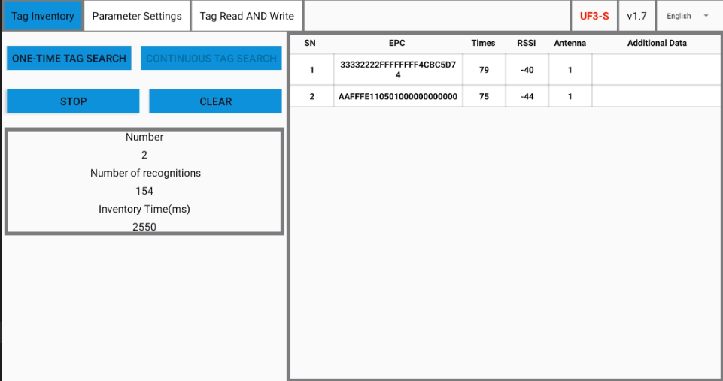

## 1.3 Stop card search

* Click Stop Card Search to stop card search and stop buzzer, and the green light is always on

## 1.4 Clear

* Click Clear to clear the tag list

# Chapter II Parameter Setting

* Output power: 0~33dBm
* The "Operating frequency band": North American standard (902~928) MHz, Chinese standard (920~925) MHz
* Work agreement: ISO18000-6C
* Antenna configuration: ANT1~ANT8, check the enabled antenna port
* GPIO operation:
  + IN1~IN4, GPI can only be gotten (high level by default)
  + OUT1~OUT4, GPO can only be set
  + If it is checked, it indicates high level, otherwise low level
* Session：S0~S3
* Profile：P1~P4
* Target：A、B
* Q value: Automatic, 0~15
* Additional data:
  + Storage area: TID, USER
  + Start address (bit): 0 by default
  + Length (bytes)
  + Access password: eight-digit hexadecimal password, 0000000 by default
  + It can only be edited when additional data is enabled; Otherwise, the edit box cannot be checked
* Temperature: in °C
* Buzzer: switch, which controls whether the buzzer rings during card search
* Hardware version
* Firmware version

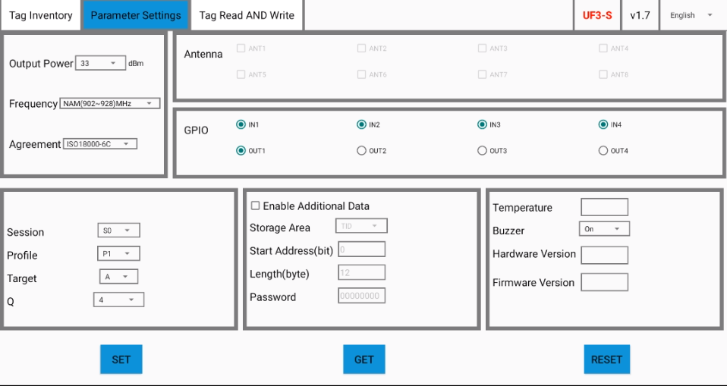

## 2.1 Set parameters

* Click Set Parameters to set parameters. If a parameter setting fails, a prompt box will pop up
* At least one port must be checked for antenna configuration

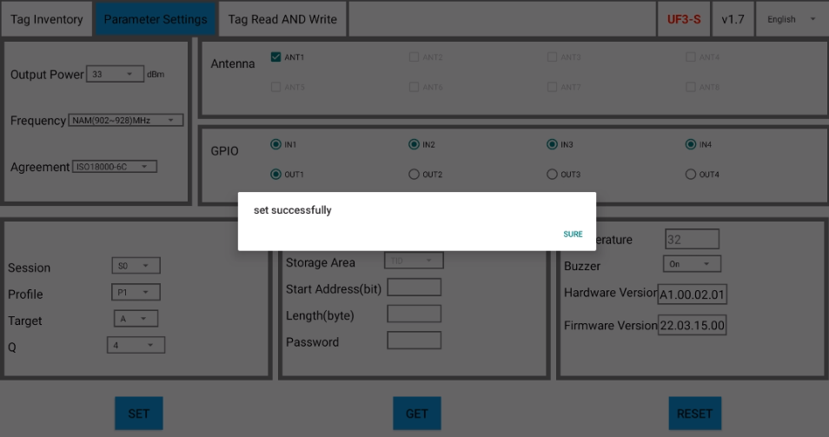

## 2.2 Get parameters

* Click Get Parameters, and the gotten parameters will be displayed on the interface immediately. If the acquisition of a certain parameter fails, a prompt box will pop up; Meanwhile, the connected antenna will be detected, and the undetected antenna port will be left unchecked

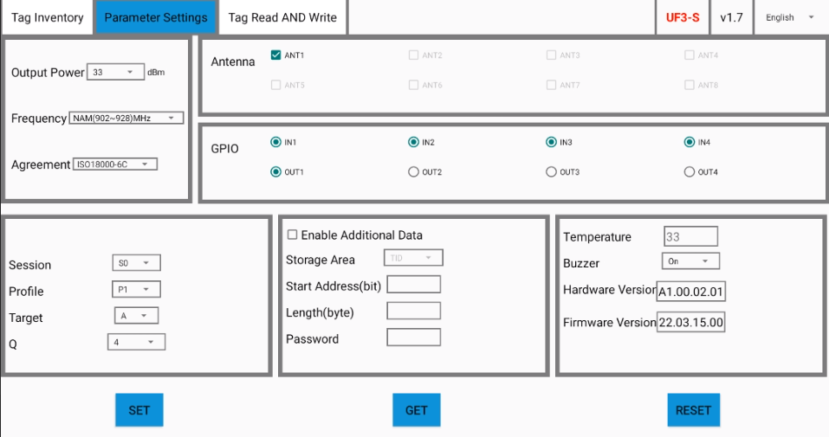

## 2.3 Restore factory settings

* Click Restore Factory Settings, and a prompt box will pop up for confirmation again. After clicking OK, the default value is as shown in the figure

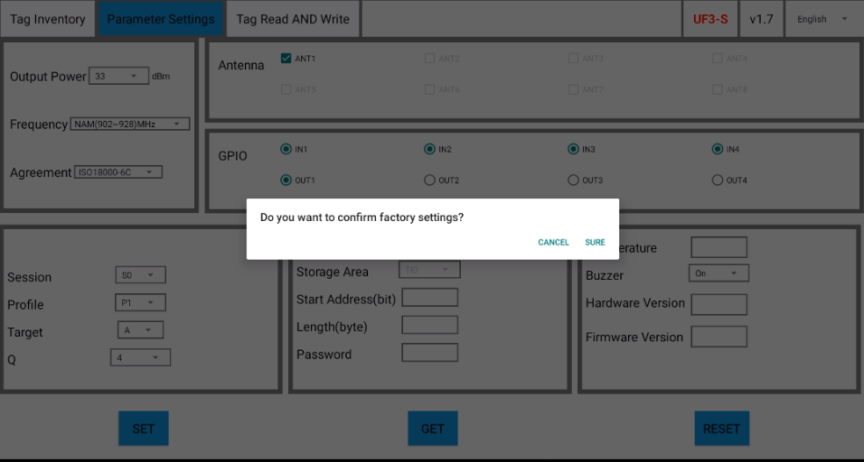

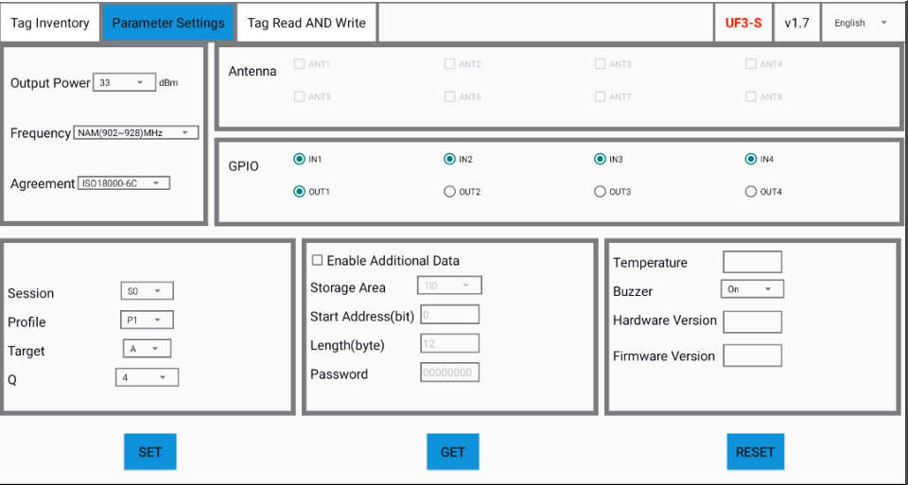

# Chapter III Tag Read and Write

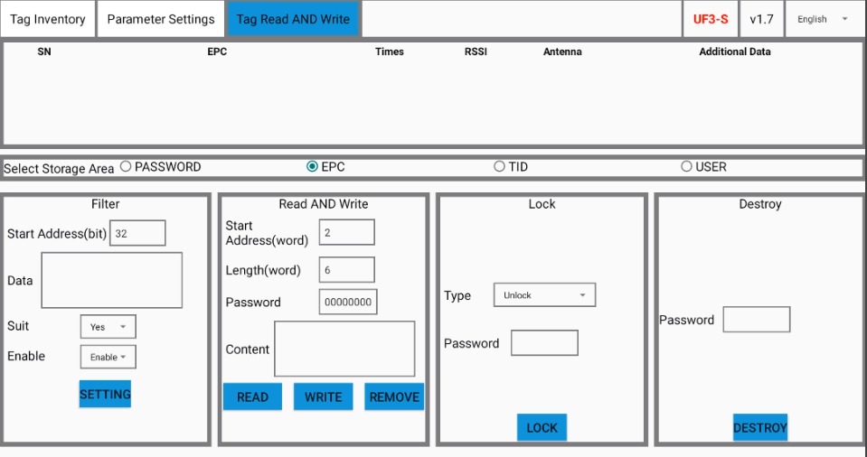

## 3.1 Set filter

* The tag list in the tag inventory interface will be synchronized to the tag read and write interface
* Click a piece of certain data in the tag list, and EPC will be synchronized to the data box in the filter, and the selected tag will be automatically filtered out, so no filter is required
* Select storage areas: PASSWORD, EPC, TID, USER
* Start address (bit): 32 by default
* Data: the data to be matched
* Match: whether to match the data
* Enable: whether to enable filter. The setting will always take effect after it is enabled, unless it is not enabled, and the filtering effect will be cleared

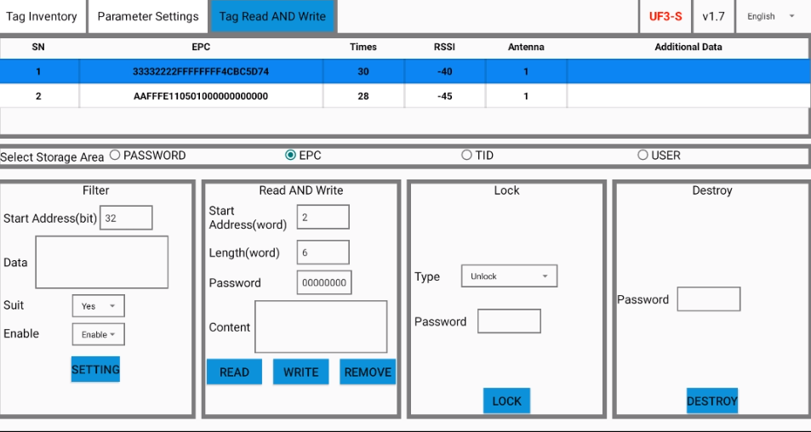

## 3.2 Read card

* Select the storage area, fill in the start address, length, access password, and then click Read Card, and the data content box will display the data
* Access password and data content are hexadecimal strings

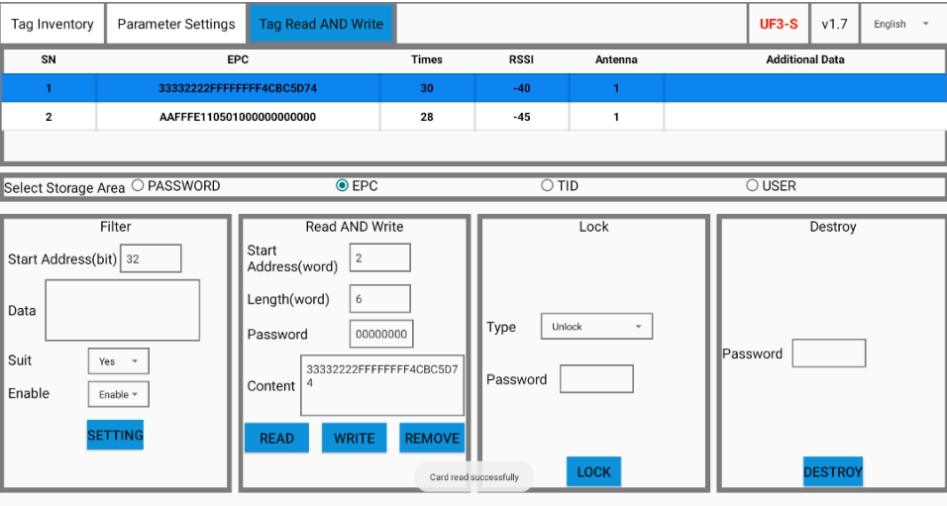

## 3.3 Write card

* Select the storage area, fill in the start address, length, access password and data content, and then click Write Card. There will be a prompt if it is successful
* Access password and data content are hexadecimal strings

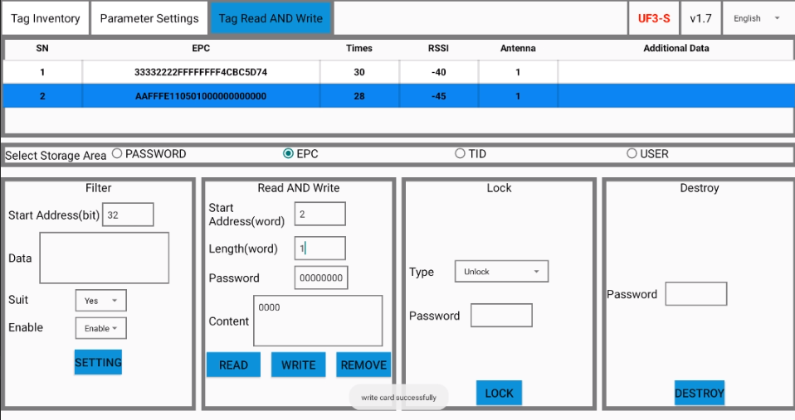

## 3.4 Clear

* Click Clear to clear the data box in the filter area and the data content box in the read and write area

## 3.5 Lock tag

* Type of lock: unlock, temporarily locked, permanently locking
* The first two words in the reserve area (PASSWORD area) are destroy password, and the last two words are access password
* Please modify the access password before locking the card (it cannot be 0000000)
* When the reserve area is locked, the modified password is required for both read and write
* When the other three areas are locked, 0000000 can be used to read, but to write (the TID area cannot be written), the modified password must be used

## 3.6 Destroy tag

* Destroy password shall be modified before destruction (it cannot be 0000000)
* After filling in new destroy password, click destroy tag to permanently destroy the tag