

AUTOID Q9L SERIES PORTABLE TERMINAL
PRODUCT SPECIFICATION V1.0

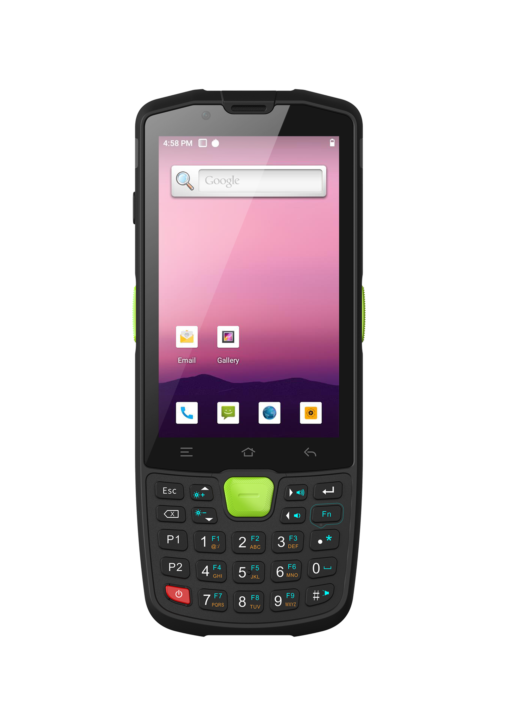

SEUIC Technologies Co., Ltd.

编订记录
文档版本 | 修订日期 | 历史记录 | 编制人 | 审阅人 | 批准人
V0.1 | 2022-2-9 | First edition of Specification | Weijie.Ma
V1.0 | 2023-2-14 | Update Specification | Weijie.Ma

- AUTOID Q9L PERFORMANCE,physics and service,environment parameter
CPU | MTK Octa core 8*2.0GHz
Operating System | Android 10.0
Memory | 4+64GB
Expansion Slot | Micro SD Card, 32GB SDHC compatible
Interface/Communication | Support Type-C, support OTG
Keypad | 27 keys
Keypad | LED (buttons with backlight)
Display | 4.0 inch size industrial grade low temperature resistant IPS screen, Capacitive, touchable, dual mode touch-with or without a thick glove/with or without wet hand
Display | 800(H)×480(W) (WVGA)
Power | Optional detachable 3.85V rechargeable 5200mAh Li-ion battery (built-in backup li-ion battery of 60mAh)
Power | Side Type-C interface, support quick charge, intelligent identification of PC and charger  End interface: support 5V/2V charging
Notification | Sound, Vibrator, LED indicator
Audio | Built-in dual loudspeaker, built-in dual microphone, Type-C support earphone
Sensor | Optical sensor, Proximity sensor, Gravity sensor, Gyroscope, E-compass
Dimension | 160(H)×66.3(W)×16.2(T)mm, (17.1mm tall with battery cover)
Weight(including standard battery) | 250g (battery included, varies by different configurations)
Operating Temp | -20℃ to + 50℃
Storage Temp | -40℃ to + 70℃ (battery excluded)
Humidity | 5% to 95% RH non-condensing
Sealing | IP67
Drop Specification | Multiple 5.8 ft./1.8m drops to marble across the operating temperature range
Tumble Specification | 1000 rounds of tumble from 0.5m, equals to 2000 impacts
ESD | ±15kV Air discharge, ±8kV direct discharge
VoLTE | Support VoLTE function
- AUTOID Q9L DATA CAPTURE OPTIONS parameter
Function 1 | 2D Image Scan Engine (option1-X3PSR)
Sensor Resolution | 1280(H)×1080(V)
Rotate | 360°
Pitch Angle | ±60°
Skew Tolerance | ±55°
Laser Safety Grade | Class II
Image Frame Rate | 60fps
Scan Depth | Code128: 7cm(3mil), 73cm(20mil)
Code Support | UPC/EAN, UPC/EAN, Code128, GS1-128, Code 39, Code 32, Code 93, Code11, Matrix 2 of 5, Interleaved 2 of 5, IATA 2 of 5, Industrial2 of 5, Codabar, MSI, Code11, PDF417, MicroPDF417, Data Matrix, Maxicode, QR Code, MicroQR, Aztec etc
Light Source System | Warm light, corss-shape laser aiming
Minimum Printing Contrast | 20%
Function 2 | 2D Image Scan Engine (option2-X3PHD)
Sensor Resolution | 1080(H)×1280(V)
Rotate | 360°
Pitch Angle | ±60°
Skew Tolerance | ±55°
Laser Safety Grade | Class II
Image Frame Rate | 60fps
Scan Depth | Code128: 9cm(3mil), 38cm(20mil)
Code Support | UPC/EAN, UPC/EAN, Code128, GS1-128, Code 39, Code 32, Code 93, Code11, Matrix 2 of 5, Interleaved 2 of 5, IATA 2 of 5, Industrial2 of 5, Codabar, MSI, Code11, etc  PDF417, MicroPDF417, Data Matrix, Maxicode, QR Code, MicroQR, Aztec, etc
Light Source System | Warm light, cross-shape laser aiming
Minimum Printing Contrast | 20%
Function 3 | 2D Image Scan Engine (option3-X3PMR)
Sensor Resolution | 1080(H)×1280(V)
Rotate | 360°
Pitch Angle | ±60°
Skew Tolerance | ±55°
Laser Safety Grade | Class II
Image Frame Rate | 60fps
Scan Depth | Code128: 10cm(5mil), 84cm(20mil)
Code Support | UPC/EAN, UPC/EAN, Code128, GS1-128, Code 39, Code 32, Code 93, Code11, Matrix 2 of 5, Interleaved 2 of 5, IATA 2 of 5, Industrial2 of 5, Codabar, MSI, Code11, etc  PDF417, MicroPDF417, Data Matrix, Maxicode, QR Code, MicroQR, Aztec, etc
Light Source System | Warm light, cross-shape laser aiming
Minimum Printing Contrast | 20%
Function 4 | GPS
Positioning System | GPS, Beidou, GLONASS (Three in one)
Frequency | GPS: L1 (1.575GHz); Beidou: B1 (1.561GHz); GLONASS: L1 (1.602GHZ)
Maximum Number of Channels | 31channels
Sensitivity | -130dB (SNR value as 40dBHz)
Accuracy | 5-10meter (OPEN SKY)
Function 5 | Camera

Front Camera
Maximum Resolution | 2592*1944 (taking photo)
Photo Function | Fixed focus
Pixel | 5 mega

Rear Camera
Maximum Resolution | 4224*3136 (taking photo), 1080P@30fps (making video)
Photo Function | Auto-foucs
Flashlight | Support flashlight, can be used for lighting
Pixel | 13 mega
Function 6 | RFID Read/Write (HF)
Standards Support | Support ISO15693, ISO14443A/B (without encryption protocol), ISO14443A tag with encryption protocol (Mifare one S50, S70 and its compatible cards); Support NFC protocol
Operating Frequency | HF frequency band 13.56MHz
Reading Range | Typical values bigger than 6cm for ISO15693, Typical values bigger than 4cm for ISO14443A, and Typical values bigger than 1cm for ISO14443B varies by different tags
- AUTOID Q9L WIRELESS DATA COMMUNICATIONS parameter
Function 1 | WLAN WIFI
Protocol | IEEE 802.11 ac/a/b/g/n/d/e/h/i/j/k/r/v/w (2.4G/5G dual-frequency WIFI)
Frequency Range | Depends on different countries(regions), 2.4GHz: 2.412GHz~2.472GHz; 5GHz: 5.17GHz~5.825GHz
Working Channel | CH1~CH13, CH34~CH165
Security | OPEN, WEP, WPA2-PSK (TKIP+AES), TLS, TTLS (MS-CHAP), TTLS (MS-CHAP v2), TTLS (CHAP), TTLSMD5, TTLS-PAP, PEAP-TLS, PEAP (MS-CHAP v2), AES, etc
Antenna | Built-in antenna
Function 2 | WWAN WCDMA
Frequency Band | European Asian area:  GSM: Quad Band (900, 1800Mhz)  TD-SCDMA: Band34, Band39  WCDMA: Band1, Band5, Band8  CDMA 1x /EVDO: BC0  TDD-LTE: Band34, Band38, Band39, Band40, Band41  FDD-LTE: Band1, Band3, Band5, Band7, Band8, Band20
Function 3 | WPAN Bluetooth
Standard | Bluetooth 5.0 (Support BLE)
Power | Class II
- AUTOID Q9L THIRD-PARTY APPLICATION DEVELOPMENT SUPPORT
System Software | Android 10.0
System Programming Environment | Android Studio
- AUTOID Q9L PERIPHRAL DEVICES AND ACCESSORIES
Standard Accessories | Universal Adapter×1, USB Cable×1, Battery×1, Hand Belt×1
Optional Accessories | Four-Slot Battery Charger, Single Slot Charging Cradle Include Battery, Four-Slot Charging Cradle, Pistol Grip, Touch Pen, Tempered Glass Screen Protector, Device Protect Cover

