**SEUIC**

**Reference** **Manual**

AUTOID Q9 Industrial Smartphone

Android Product UserManual

Version 1.0

SEUIC Technologies Co., Ltd.



**Copyright** **Notice**

The information contained in this manual is provided on an "AS IS" basis and is subject to change without further notice.

Seuic makes no warranties of any kind with respect to the contents of this manual, including, but not limited to, implied warranties of merchantability and fitness for a particular purpose. Seuic shall not be liable for errors contained in this manual or for incidental or consequential damages arising out of the supply, performance, or use of this manual or the examples contained herein.

Software Copyright**2021** **SEUIC** **Company**

If you need more product information and support, please contact our sales representative, or go to our website directly.

SEUIC Technologies Co., Ltd.

15 Xinghuo Road, Jiangbei New Area, Jiangsu, China

Postcode: 210032

Phone: 86-25-52261298

Fax: 86-25-52268995

Corporate Website: [www.Seuic.com](http://www.seuic.com)

Product Website: [www.ChinaAUTOID.com](http://www.chinaautoid.com)

Service Hotline: 4006770876

Service Email: AUTOID@seuic.com



**Contents**

Chapter 1. Instructions for Use 5

1.1 Cautions for laser scanning engines 5

1.2 Cautions for safety 5

1.3 Cautions for maintenance 5

Chapter 2. Appearance 7

Chapter 3. Keyboard 10

Chapter 4. Quick Start Guide 12

4.1 Power on 12

4.2 First use 12

4.3 Power off 12

4.4 Restart 12

4.5 Install SIM card 12

4.6 Install SD card 13

4.7 Install battery and battery cover 13

Chapter 5. About Charging 14

5.1 Charging time 14

5.2 Charging temperature 14

5.3 Battery charging 14

5.4 Cautions for battery use 14

5.5 LED indicators 15

Chapter 6. Main screen 16

6.1 Status bar icons 16

Chapter 7. Settings 18

7.1 Network & internet 18

7.1.1 WLAN 18

7.1.2 Mobile network 24

7.1.3 Data usage 28

7.1.4 Hotspot & tethering 28

7.1.5 VPN 30

7.1.6 Airplane mode 30

7.2 Connected devices 30

7.2.1 Bluetooth 31

7.2.2 NFC 35

7.3 Apps & notifications 35

7.4 Battery 35

7.5 Display 36



7.6 Sound 39

7.7 Storage 40

7.8 Location 41

7.9 Security 41

7.10 Accounts 42

7.11 Accessibility 43

7.12 System 44

7.12.1 Languages & input 44

7.12.2 Gestures 45

7.12.3 Date & time 45

7.12.4 Reset options 46

7.12.5 About phone 47

Chapter 8. Introduction of typical applications 48

8.1 Scanner 48

8.2 System Update 53

8.3 Mobile Butler 55

8.4 Quick Configuration 62

8.4.1 Import 62

8.4.2 Export 65

8.4.3 User Configuration 67

8.5 Feature Key Settings 69

8.5.1 Fn Sticky Keys 70

8.5.2 Block P5 Function Key 70

8.5.3 Block P7 Function Key 70

8.5.4 Touchscreen Glove Mode 70

8.5.5 Disable Status Bar Dropdown 71

8.5.6 Prohibit Passing Scan Key Value to Apps 71

8.5.7 Show Scan Float Button 71

8.5.8 Hardware Keyboard Tones 71

8.5.9 Prohibit Fall Detection 71

8.6 Digital Certificates Whitelist 71

8.7 Hotkey Settings 74

Chapter 9. Troubleshooting 78

Optional Accessories 80





**Chapter** **1.** **Instructions** **for** **Use**

**1.1** **Cautions** **for** **laser** **scanning** **engines**

 Laser radiation! Do not look directly at the laser beam.

**1.2** **Cautions** **for** **safety**

Use only the batteries and chargers specified by our company for your device. Using other products may result in battery leakage, overheating, bursting and fire.

Do not short the charger as this may cause electric shock, smoke and damage to the charger.

Do not use the charger with a damaged power cord, as this may lead to fire and electric shock.

Do not disassemble or modify the charger as this may result in personal injury, electrical shock, fire and damage to the charger.

Grasp the charger when unplugging; pulling the power cord may damage the cord and cause electrical shock and fire.

Clean the device, battery and charger with a soft, dry cloth.

Do not wipe the equipment with alcohol, thinner or benzene solutions.

**1.3** **Cautions** **for** **maintenance**

This product is waterproof and dustproof, but should not be operated in extreme high temperature, low temperature or wet environment. Please refer to the product specifications for temperature and humidity standards.

Pressing the screen with force may damage the screen. Do not touch the screen with aresistive touchscreen pen to avoid scratching or damaging the screen. To clean the screen, spray a small amount of commercial LCD cleaner on a soft cloth.



Do not spray cleaner directly on the screen.

Do not use any chemical cleaner to wipe the LCD screen.

Keep the scan window clean and free of smudges and do not carve or scrape with sharp objects.

If this product is not used for long, be sure to download the data to your computer for storage.

It will take a long time to charge the battery when the device is usedfor the first time or reused afterlong storage.

If there is a malfunction, write down the information about themalfunction and contact the service personnel.

**Chapter** **2.** **Appearance**

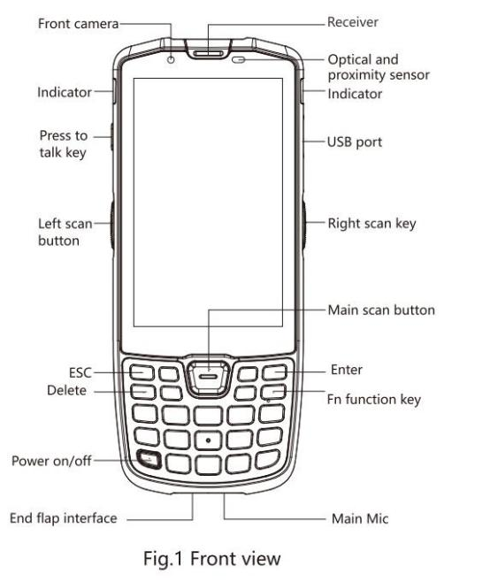

Figure 2- 1 Front View



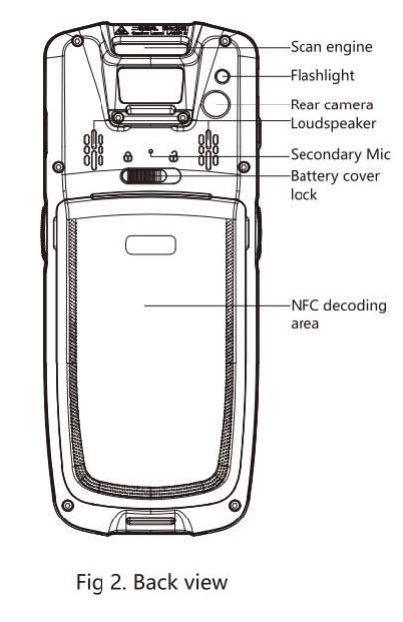

Figure 2-2 Back View



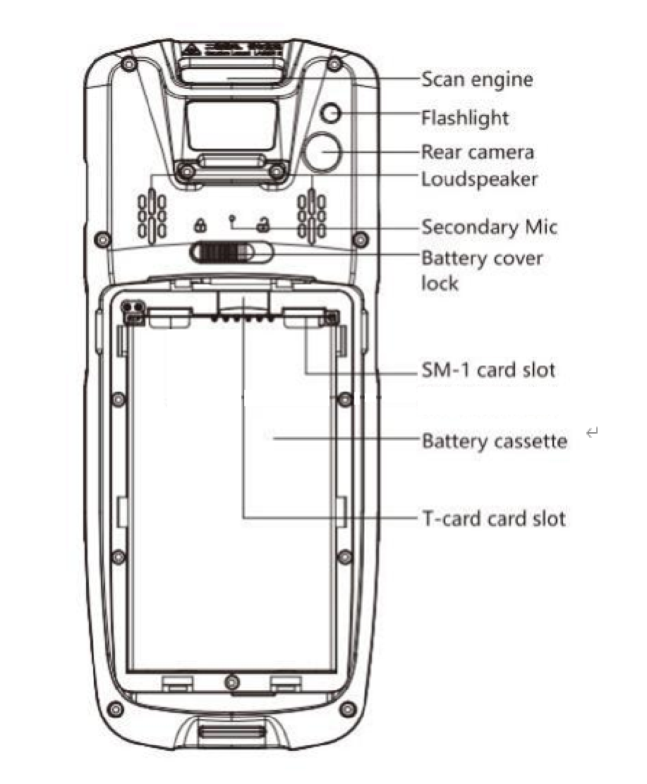



Figure 2-3 Battery Compartment Back View



**Chapter** **3.** **Keyboard**

The keyboard on the AUTOID Q9 device is 24 keys + 2 side scan keys+ 1 PTT key, and there are 3 buttons on the touchscreen (Menu, Home, Back).

Keys Description:

Table 3- 1 Keys Description

|  |  |  |
| --- | --- | --- |
| **Key** | **Main** **Function** | **Description** |
|  | Home button | Press to return to Home screen. |
|  | Task button | Press to display opened applications. |
|  | Back button | Press to return to the parent screen or exit the  application.  In the text entry screen, press to close the on-  screen keyboard |
|  | Scan key | Scan key for barcode scan. |
|  | Side-Scan key | Scan keyfor barcode scan. |
|  | PPT key | Intercom function, press and hold to talk to each  other. |
|  | ESC key | Exit |
|  | Delete key | Delete |
|  | Direction key: up | Becomes Backlight+ in Fn mode |
|  | Direction key: down | Becomes Backlight- in Fn mode |
|  | Direction key: left | Becomes Volume+ in Fn mode |
|  | Direction key: right | Becomes Volume- in Fn mode  Long-press together with Power key for screenshot  function. |



|  |  |  |
| --- | --- | --- |
|  | Enter key | Confirm |
|  | Fn Lock key | Lock keyboard input for Fn function input |
|  | 1 | Number 1, Symbol@:/  Becomes F1 key in Fn mode |
|  | 2 | Number 2, Letters A.B.C  Becomes F1 key in Fn mode |
|  | 3 | Number 3, Letters D.E.F  Becomes F1 key in Fn mode |
|  | 4 | Number 4, Letters G.H.I  Becomes F1 key in Fn mode |
|  | 5 | Number 5, Letters J.K.L  Becomes F1 key in Fn mode |
|  | 6 | Number 6, Letters M.N.O  Becomes F1 key in Fn mode |
|  | 7 | Number 7, Letters P.Q.R.S  Becomes F1 key in Fn mode |
|  | 8 | Number 8, Letters T.U.V  Becomes F1 key in Fn mode |
|  | 9 | Number 9, Letters W.X.Y.Z  Becomes F1 key in Fn mode |
|  | Custom keys | Configurable as per user requirements |
|  | Power button | Sleep/wake up, shutdown |
|  | . | Symbol .  Becomes * key in Fn mode |
|  | 0 | Number 0  Becomes Space in Fn mode |
|  | # | Enter factory pattern/the same function as the # key on the mobile phone |



**Chapter** **4.** **Quick** **Start** **Guide**

**4.1** **Power** **on**

Take out the device and the battery, slide the battery cover lock to open state, install the battery and close the battery cover, then slide the battery lock to close the cover, and press and hold the power button to turn on the device.

**4.2** **First** **use**

The first time you boot up or open some applications, a quick tutorial will pop up to guide you through using your PDA.

When in the system working state, press the power button to wake up the device. When in the sleep state, press the power button to wake up the system and light up the screen.

**4.3** **Power** **off**

Press and hold the power button to open an option menu, tapPower Off to shut down the device.

**4.4** **Restart**

When the device is powered on under non-sleep state, press and hold the power button for 2s to open the power menu, then select Restart and tap Confirm to turn off and restart the device normally.

**4.5** **Install** **SIM** **card**

Follow the instructions below to install Nano SIM card:

Remove the battery, and the left card holder is a Nano SIM- 1 card holder, follow



the direction on the label and insert the Nano SIM- 1 card; the right card holder is a Nano SIM-2 card holder, follow the direction on the label and insert the Nano SIM-2 card.

**4.6** **Install** **SD** **card**

Follow the instructions below to install SD card:

Remove the battery, the center card holder is the memory card holder, and follow the direction on the label to insert the memory card.

**4.7** **Install** **battery** **and** **battery** **cover**

Slide the battery cover lock to the right side to unlock, remove the cover and then the battery. Install the battery and cover as labelled, slide the cover lock to the left side to lock up.



**Chapter** **5.** **About** **Charging**

Since the battery only has a small amount of power for testing before shipping out of the factory, it must be charged first when received before use. The device can be charged via a USB Cable, Single Charging Dock or Tetra Charging Dock.

**5.1** **Charging** **time**

Battery: first charge takes about 3 hours chargingvia the adapter. The LED lights up in solid red when charging and turns solid green when fully charged.

**5.2** **Charging** **temperature**

The best operating temperature is room temperature 18~25C. Batteries will not be charged at temperatures below 0°C or above 50°C.

**5.3** **Battery** **charging**

The battery can also be charged separately using a Single Charging Dock for the device or a Tetra Charging Dock for the battery.

Tip: If this product is not used for long, please charge the device at least once every two months.

**5.4** **Cautions** **for** **battery** **use**

 If the battery is exhausted, it is normal that the device may not power on

immediately when plugged in the charger. Please keep charging for a period of time before powering on.

 The battery can be recharged repeatedly, but is consumable and should be

replaced when the device standby time is significantly reduced.

 The charging time of the battery varies according to the temperature



conditions and battery usage, so please charge the battery within a reasonable temperature.

 When the battery level is low, the device will pop up a low battery alert.

When the battery level is too low, the device will automatically turn off.

**5.5** **LED** **indicators**

The LED indicators on both sides of the device indicate the battery status and charging status in different colors.

 When NOT connected to the USB or charging adapter, the flashing red light

on the right-side LED indicates that the battery is too low and should be charged in time.

 When connected to the USB or charging adapter, the solid red light on both

side LEDs indicates that the battery is charging.

 When connected to the USB or charging adapter, the solid green light on

both side LEDs indicates that the battery is fully charged.

 When the device scans a barcode, the LEDs on both sides flash once in green,

indicating that the barcode has been read.



**Chapter** **6.** **Main** **screen**

AUTOID Q9 has two home screens, configurable at your preference.

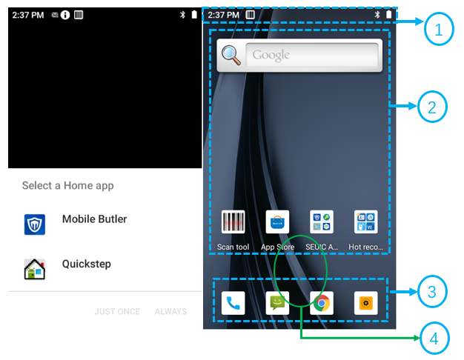

Figure 6- 1 Main Screen

Table 6- 1 Main Screen Items

|  |
| --- |
| ① Status Bar: displays notifications and status icons. |
| ② Display Area: used to p lace application icons, desktop folders and widgets. |
| ③ Shortcut Bar: tap to enter the corresponding application. |
| ④ Application Tray: slide up to enter the main screen to view all applications. |

**6.1** **Status** **bar** **icons**

The status bar icons and the notification bar icons are located at the top of the screen and display device status information and notifications, as shown in the table below.



|  |  |  |  |
| --- | --- | --- | --- |
| **Icon** | **Description** | **Icon** | **Description** |
|  | Available WLAN network detected |  | No SIM card |
|  | Connected to WLAN network |  | Signal strength |
|  | Portable WLAN enabled |  | Mobile network connected |
|  | Vibration mode |  | Airplane mode |
|  | Missed call |  | Scan ON |
|  | New message |  | Battery charging |
|  | Screenshot captured |  | Battery fully charged |
|  | Alarm clock |  | Low battery |
|  | Preparing the microSD card |  | Multiple notification icons, out of display range |
|  | Bluetooth |  | GPS locating |
|  | Uploading data |  | Downloading data |
|  | USB debugging |  |  |

Table 6-2 Status Icons and Notification Bar Icons



**Chapter** **7.** **Settings**

**7.1** **Network** **&** **internet**

Find this icon: 

-> Settings

->Network & internet

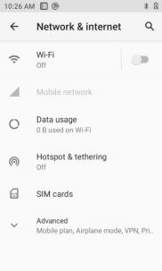

Figure 7- 1 Network & internet

**7.1.1** **WLAN**

Wi- Fi 2.4G provides a wireless network access range of up to 450 feet (150m), and Wi- Fi 5G provides a range of up to 300 feet (100m) (Note: industrial-grade APs, open space). To use the Wi- Fi on your device, you must connect to a wireless access point or hotspot.

Note: Wi- Fi signal availability and coverage depends on the signal number, the infrastructure, and the objects that the signal penetrates.

Turn on Wi- Fi and connect to a wireless network

1. Tap the WLAN Off/On button to enable Wi- Fi, And the system automatically



scans for available wireless networks.

2. The Wi- Fi network list will then display the network names and security settings (open or encrypted) of the discovered Wi- Fi networks.

3. Tap one of the Wi- Fi networks to connect. When you select an open network, you are automatically connected to that network. If you select an encrypted network,

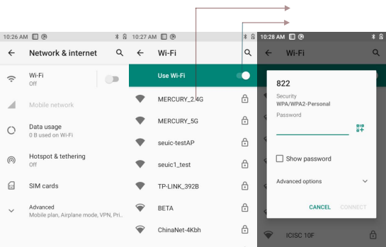

you must first enter the appropriate password before connecting.

 Tap to connect to the

network

 Tap to open and

search network

Figure 7-2 Wi-Fi menu

4. WLAN Frequency Band ([WLAN Advanced Settings] --> [WLAN Frequency Band]), when you choose to use only 5GHz/2.4GHz, you can only search for APs in 5GHz/2.4GHz.



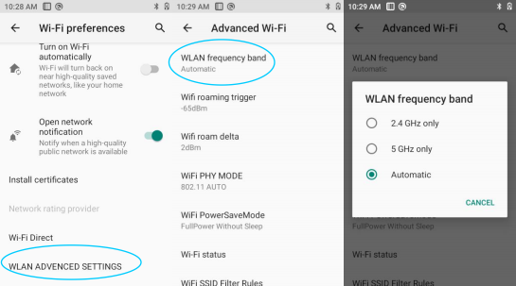

Figure 7-3 WLAN Frequency Bands

5. Roaming RSSI Threshold and Roaming RSSI Difference can be set on demand through Advanced Settings.

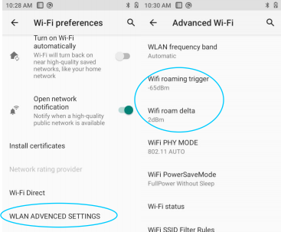

Figure 7-4 WLAN roaming settings

(1) Roaming RSSI Threshold: if the actual signal strength of the current connect AP is less than the threshold value (premise: in a roaming environment), then the roaming will be triggered. As shown in the figure, the roaming threshold value is set to -65d Bm, when the signal strength is lower than that, the roaming mechanism is triggered.



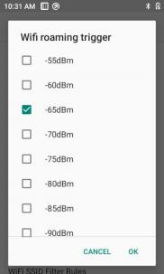

Figure 7-5 WLAN Roaming RSSI Threshold

(2) Roaming RSSI Difference: when the difference of signal strength between the two APs reaches the set value, roaming is triggered to connect to the AP with better signal strength. As shown in the figure, when the difference of signal strength between the two APs is greater than 5dBm (also need to reach the Roaming RSSI Threshold standard), roaming can start normally.

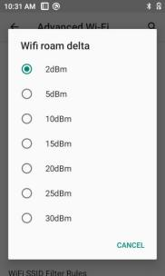

Figure 7-6 WLAN Roaming RSSI Difference

WIFI Operating Mode configuration supports configuring fixed operating mode (a/b/g/n/ac), which by default is 802.11 AUTO.



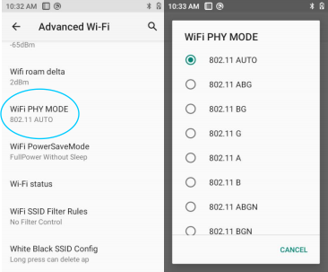

Figure 7-7 WIFI Operating Mode Configuration

7. Set Power Saving Mode. There are three modes: power saving, full power, full power but power saving when asleep. The default is power saving mode. [ Power Saving] means always take power saving measures; [ Full Power] means always take active mode and consume more power; [ Maximum Performance] means have the best performance experience but consume the most power. As shown below:

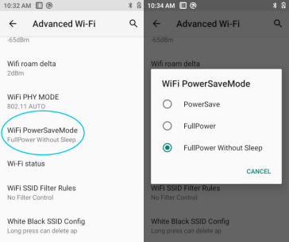

Figure 7-8 Power Saving Mode

8. Black/White List Policy and Configure Black/White List



(1) Black/white list policy has three types of rules: no filtering rules, display only whitelisted APs, and hide blacklisted APs, as shown below:

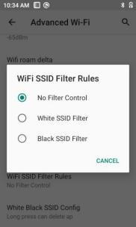

Figure 7-9 Black/White List Policy

(2) Configure Black/White List includes blacklist management and whitelist management.

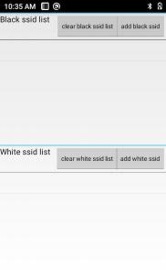

Figure 7- 10 Configure Black/White List

Note: When the device is connected to a wireless network, the status bar

displays the Wi- Fi icon() and the approximate signal strength (number of lit bars).



If you touch the wireless network to which the device is currently connected, the Wi- Fi network name, status, signal strength, frequency, security information, MAC address, IP address, gateway, subnet mask, DNS, connection speed, and IPv6 address are displayed.

If you want to remove a wireless network setting on your device, tap on the connected AP and select Forget, which will delete this AP as shown in the image to the right

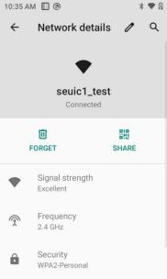

Figure 7- 11 Deleting or Modifying a Network

Note: Once the Wi- Fi is switched on and off again, the device does not need to re-enter the appropriate password to connect to a previously connected encrypted wireless network. The Wi- Fi network will search for itself, not requiring additional steps to connect to the Wi- Fi network.

Connect to other Wi- Fi networks

 In the Wi- Fi screen, tap Scan. The Wi- Fi networks discovered will be displayed in

the Wi- Fi network list.

 Tap another Wi- Fi network to connect to that network.

**7.1.2** **Mobile** **network**

1. Turn on mobile data network : [Settings] --> [ Network & internet] --> [ Mobile



network]. If mobile data is enabled, related mobile data usage will be recorded and incur data costs.

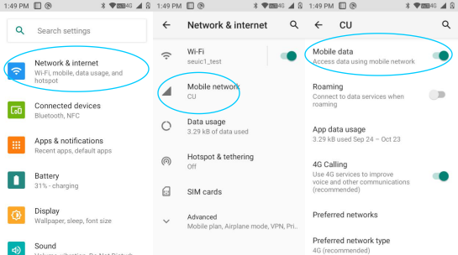

Figure 7- 12 Enable mobile network

2. Roaming: if enabled, data traffic can directly switch to roaming status when in a roaming environment.

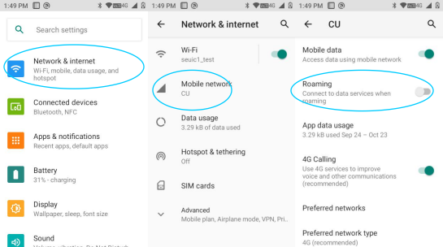

Figure 7- 13 Mobile data roaming

3. Network type: insert different SIM card, system automatically identifies the network type according to the SIM card type. The default network type is 4G (recommended).



After selecting the preferred network type, the taskbar will display the corresponding network signal indicator 2G=2G preferred, 3G=3G preferred, 4G=4G preferred. If a China Unicom card selects the network type 2G preferred, the device will forcefully downgrade to 2G network even if there is 3G signal coverage.

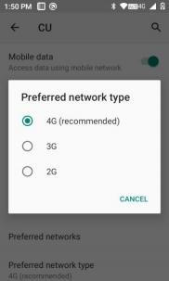

7- 14 Mobile network type selection

4. Access point names. Generally, China Mobile default is cmnet, China Unicom default is ctnet, as shown below:

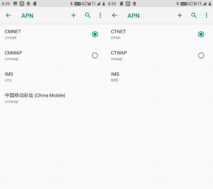

Figure 7- 15 Access Point Names APN

5. Add dedicated APN, tap  button, and tap New APN, then a pop-up interface will be shown as below, which generally requires adding the name (custom),



APN (network access point), user name, password, etc. Then press  button to select save or press the Back button directly to return to complete adding the config.If to modify or delete the added APN, tap to enter for modification, and press  button to save or delete, etc., as shown in the figure.

Note: When adding an APN, other options can be set according to the user's own access point requirements.

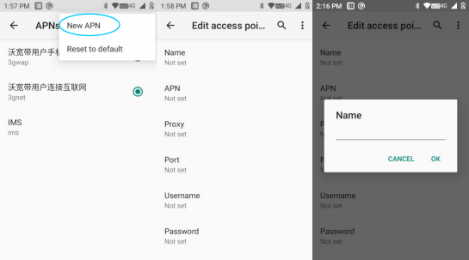

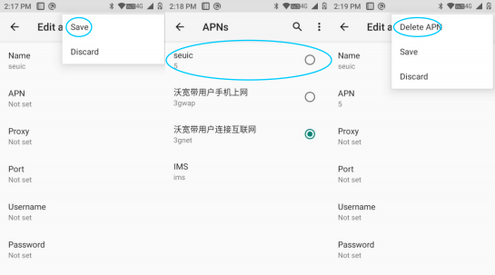

Figure 7- 16 Adding and Deleting APN

6. Network provider: searches for network provider resources in the current



environment.

**7.1.3** **Data** **usage**

Open mobile data to set the mobile data limit.

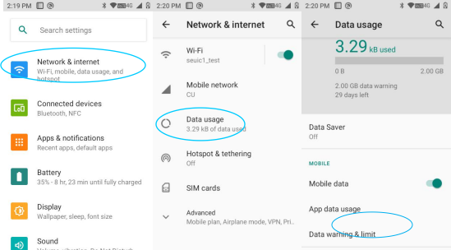

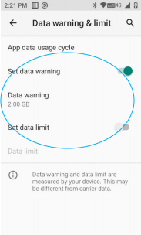

Figure 7- 17 Data usage

**7.1.4** **Hotspot** **&** **tethering**

(1) Portable hotspot function, which uses this device as a Wi- Fi hotspot to provide signal access to cell phones and computers with Wi- Fi modules within a



certain range.

(2) Settings --> Network & internet --> Hotspot & tethering --> WLAN Hotspot -- > On, as shown below:

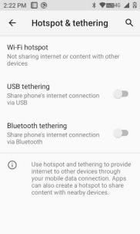

Figure 7- 18 Portable Hotspot Setting

(3) Configure a portable hotspot, as shown below:

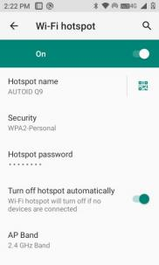

Figure 7- 19 Modify a WLAN Hotspot

(4) The other party can search for the hotspot, enter the corresponding password to share the hotspot network of the device.



**7.1.5** **VPN**

After enabling VPN, you need to add a VPN private network (e.g., to access the company's internal file server and other shared resources). Then, no matter where you are, you can connect to the company's VPN server through the VPN client. You can dial through the VPN client after getting your VPN account, and access the company's shared resources once dialed successfully.

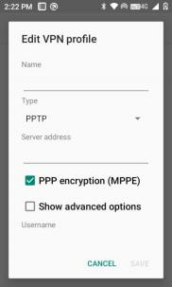

Figure 7-20 VPN Settings

**7.1.6** **Airplane** **mode**

When the airplane mode is checked, the wireless module will automatically turn off.

**7.2** **Connected** **devices**

Find this icon: 

-> Settings

-> Connected devices





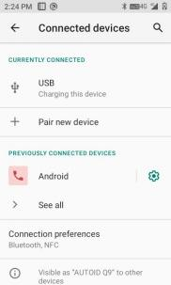

Figure 7-21 Connected Devices

**7.2.1** **Bluetooth**

1.Tap the Connected Devices button to search for other Bluetooth devices and pair with a new device.

2. From the list of discovered devices, tap on the device to be connected to pair.

3. After entering the PIN code in the pairing request pop-up dialog, tap Pair to connect the device.

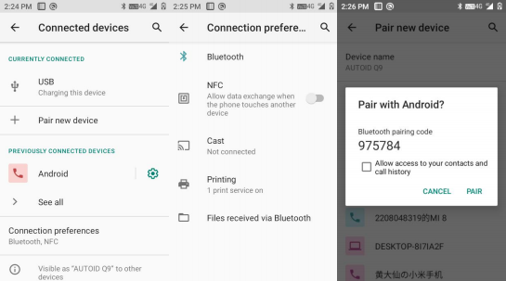



Tap to turn on and search for Bluetooth



Figure 7-22 Bluetooth

4. Tap the right-side setting button to rename or forget or configure other settings for the successfully paired device.

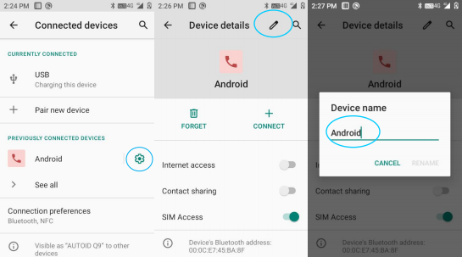

Figure 7-23 Paired Bluetooth Device Settings

5. Bluetooth transmission: you can choose the documents, pictures, videos, MP3 and other files to be sent through Bluetooth. For example, to share pictures, press and hold the pictures you want to share in the file manager, and in the sharing interface select the Bluetooth device you want to send to. Then a details interface



appears, where you can confirm to send the pictures, as shown below:

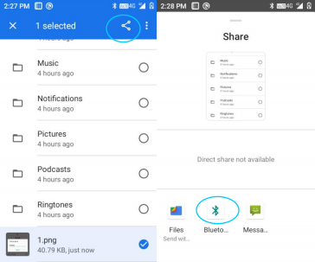

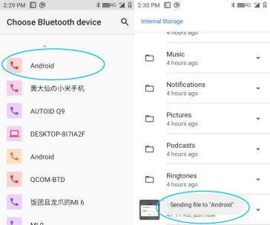

Figure 7-24 Bluetooth Transmission

6. When sending, there is an upward arrow mark on the top left screen, which you can pull down to view the transmission progress, as shown below:





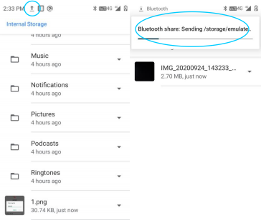

Figure 7-25 Bluetooth Transmission Progress Bar

7. There is a corresponding notification when the files are sent.

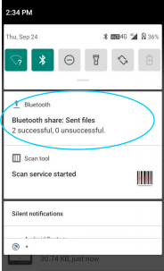

Figure 7-26 Bluetooth shared results view

8. Paring for Bluetooth earphone is the same as normal Bluetooth pairing. Bluetooth earphone can be used for voice communication and multimedia playback.



**7.2.2** **NFC**

NFC function. By enabling this function and installing third-party NFC software, you can read and write RFID cards.

**7.3** **Apps** **&** **notifications**

Find this icon: 

-> Settings

-> Apps & notifications

Apps and notifications (recent apps, notifications, app permissions, default apps, emergency alerts, special app permissions).

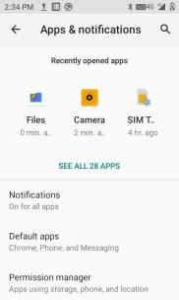

Figure 7-27 Apps & Notifications

**7.4** **Battery**

Find this icon: 

-> Settings

->Battery



View current battery capacity and usage time.

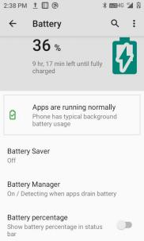

Figure 7-28 Battery

**7.5** **Display**

Find this icon: 

-> Settings

-> Display

1. Brightness level : move the cursor bar left and right to adjust the backlight. [Adaptive brightness] : optimize the brightness according to the ambient light conditions.



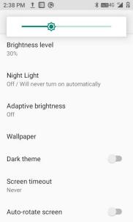

Figure 7-29 Display

2. Wallpaper: After entering, you can freely modify the wallpaper source as desired. [ Dynamic wallpaper] : system built-in default dynamic wallpapers. [Gallery] : photo albums or pictures on the memory card. [Wallpaper] : system built-in default wallpapers.

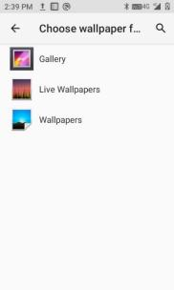

Figure 7-30 Wallpaper

3. Screen timeout : sets the timeout before system sleep. Upon the set time, the system will automatically sleep.



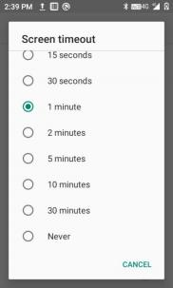

Figure 7-31 Dormancy

4. Font size, adjust the system font size according to your needs.



Figure 7-32 Fonts

5. Auto-rotation (only supported on standard models) : auto-rotation ON: automatically switch between horizontal and vertical screen according to the rotation angle of the device; auto-rotation OFF: keep the screen in portrait orientation, not changing with the rotation angle of the device.



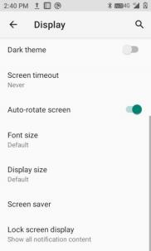

Figure 7-33 Auto Rotation

**7.6** **Sound**

Find this icon: 

-> Settings

-> Sound

Settings for volume, phone ring tone and default notification tone, where you can also turn on/off to enable/disable ringtone and vibration for incoming calls, dial pad tones, screen locking sounds, charging sounds, touch sounds and touch vibration, as shown in below:



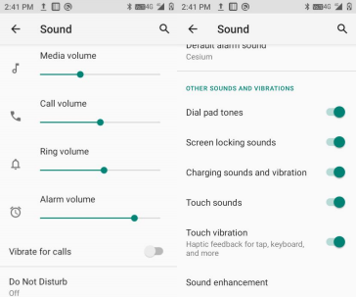

Figure 7-34 Sounds and Notifications

**7.7** **Storage**

Find this icon: 

-> Settings

-> Storage

You can view the available internal storage space, SD card storage space, and external USB flash drive storage space.

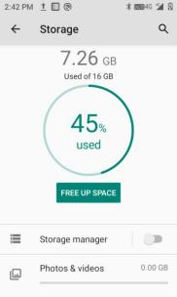





Figure 7-35 Storage

**7.8** **Location**

Find this icon: 

-> Settings

-> Location

1. Turn on Use Location to enable GPS locating function. You can download third-party locating software’s.

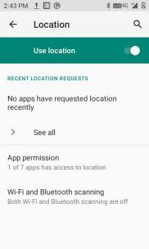

Figure 7-36 Location

**7.9** **Security**

Find this icon: 

-> Settings

-> Security

Set screen lock mode, device admin apps, unknown source application installation password settings, SIM card lock, screen pinning, etc.



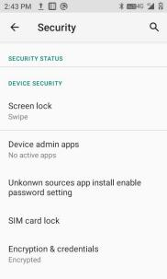

Figure 7-37 Security and Location Information

The system by default restricts installing application from an unknown source. If you want to install it, please enable "Install from Unknown Source" in the feature settings, you will be prompted to enter a password before you can install the corresponding app (default password: 4007770876).

In the Unknown Source Application Installation Password Settings item, you can change the corresponding password.

**7.10** **Accounts**

Find this icon: 

-> Settings

-> Accounts

Set up accounts and sync data (you can sync contact information, calendars, etc., to other product clouds, but you need to set up appropriate accounts and server).



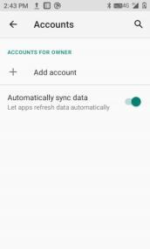

Figure 7-38 Users and Accounts

**7.11** **Accessibility**

Find this icon: 

-> Settings

-> Accessibility

Here you can set up the system, caption, magnification, large font size, high- contrast text, power button ends call, auto-rotate screen, speak your password, accessibility shortcuts, text-to-speech (TTS) output, and touch & hold delay.

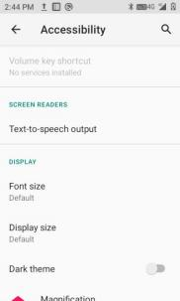

Figure 7-39 Accessibility



**7.12** **System**

Find this icon: 

-> Settings

-> System

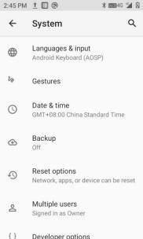

Figure 7-40 System

**7.12.1** **Languages** **&** **input**

Select your language, choose your preferred keyboard and input method, spell check tool, autofill service, personal dictionary, pointer speed, and text-to-speech (TTS) output.



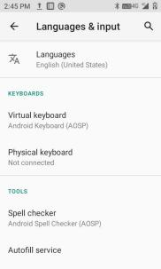

Figure 7-41 Languages & Input

**7.12.2** **Gestures**

If enabled, press the power and volume-up buttons (downwards-arrow and

right-arrow buttons in FN mode) simultaneously to switch to selected mode.

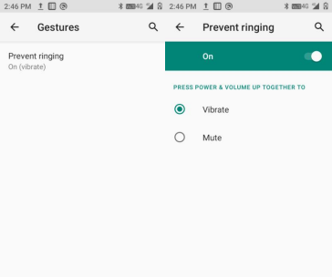

Figure 7-42 Gestures

**7.12.3** **Date** **&** **time**

You can use network-provided time or time zone, or manually set the date and



time and select the time zone. You can also select the format in which the time and date are displayed.

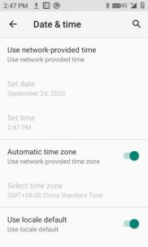

Figure 7-43 Date & Time

**7.12.4** **Reset** **options**

Reset WLAN, mobile data network& Bluetooth, reset app preferences, and erase all data (factory reset)

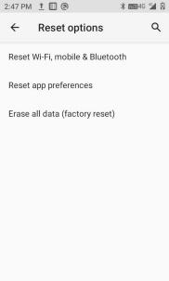

Figure 7-44 Reset options



**7.12.5** **About** **phone**

Device details.

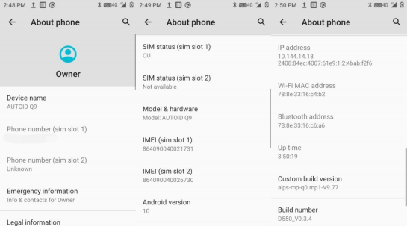

Figure 7-45 About Phone

1. Device name

2. Phone number

3. Emergency information (info & contacts for Owner)

4. Legal information: third-party licenses, system WebView licenses, wallpapers

5. SIM status: network, phone number on SIM, mobile network state, service state, signal strength, mobile voice network type, mobile data network type, roaming, EID

6. Model & hardware: model, serial number, device serial number, user-defined serial number, function number

7. IMEI: IMEI, IMEI SV

8. Android version: 10

9. IP address

10. WLAN MAC address

11. Bluetooth address

12. Build number



**Chapter** **8.** **Introduction** **of** **typical**

**applications**

**8.1** **Scanner**

1.Find this icon , enter the application interface and tap on Scan for scanning.

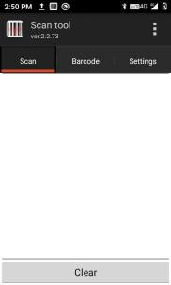

Figure 8- 1 Scanner Main Interface

2. Select [ Barcode Settings] to enter interface to set the desired barcode type.



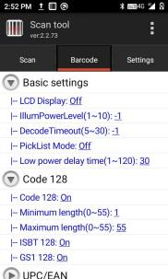

Figure 8-2 Barcode settings

3. 2D barcode: open Basic Settings to configure scanning security level, lighting, duration of light, exposure, focus mode, etc. : (as shown in Figure 8-4 below)

Note: There are differences in the basic settings for different models of scanner. Please refer to the specific settings of your model.



Figure 8-4 2D Scanner Basic Settings Interface

4. Open [Application Settings], where you can turn on/off settings for scanning, as shown in Figure 8-5:

(1) Scan sound : if on, sound alert during scan.



(2) Scan indicator light: if on, logo indicator light in solid green during scan.

(3) Vibration: if on, vibration during scan.

(4) Barcode appending: if on, continuous output of barcode.

(5) Auto-clear: auto clear the last barcode after successful scan.

(6) Autostart : if enabled, auto start the scanner application upon boot.

(7) Show barcode type: if enabled, show barcode type during scan.

(8) Filter invisible characters: if enabled, filter the invisible characters in barcode.

(9) Filter barcode opening and closing spaces: if enabled, filter the opening and closing spaces in barcode.

(10) Hold to scan: if enabled, the scanning light immediately goes out when the scan key is released; if disabled, the scanning light continues until the [Scanning Duration] is reached after the scan key is released.

(11) Repeat scan: if enabled, the scan will automatically go on continuously.

(12) Interval time: configurable, the interval time from the completion of barcode scanning to the next scan.

(13) Restore barcode default: can restore the barcode default settings, as shown in Figure 8-6.

(14) Barcode suffix: can add barcode output suffix (can be numbers, letters, special characters, etc.).

(15) Barcode prefix: can add barcode output prefix (can be numbers, letters, special characters, etc.).

(16) Terminating symbol : can choose the barcode terminating output character, including: Enter, Tab, Space, None.

(17) Barcode sending mode: can choose to send the barcode by focus entry, broadcast mode, simulate keyboard or clipboard mode (simulate keyboard needs to select the input method that supports hard keyboard), as shown in Figure 8-7.

(18) Developer options: enter the password 888888 in order to modify the developer options (not recommended), as shown in Figure 8-8.





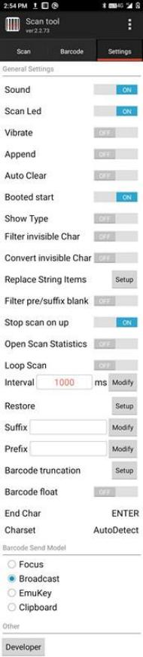

Figure 8-5 Application Settings



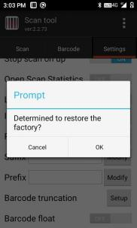

Figure 8-6 Restore Barcode Default

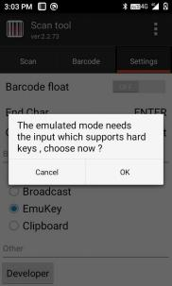

Figure 8-7 Simulate Keyboard Settings

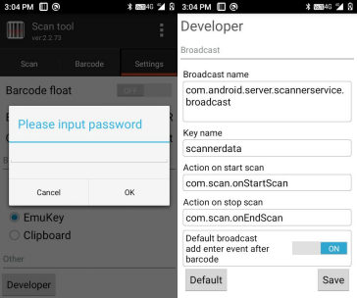

Figure 8-8 Developer Options

5. Program Hide or Exit

(1) Select [ Hide], the program will run in the background, and allows scan by pressing scan key in any editing interface.

(2) Select [ Exit], the program will exit and close.



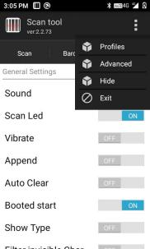

Figure 8-9 Hide and Exit

**8.2** **System** **Update**

This application allows easy remote system update for customers.

1. Find this icon  and go to [System Update], as follows:

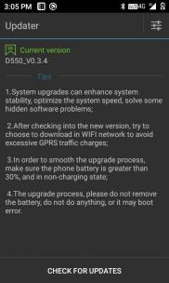

Figure 8- 10 System Update

2. With internet access, tap the check-for-update button. If there is no update, it will show that the current version is the latest version; if there is an update, it will



show a newer version is found, tap to enter the download screen, as shown below.

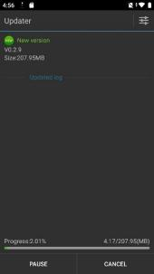

Figure 8- 11 Check for Update and Download

3. Tap Download. Once downloaded, tap Update Immediately and the device will restart into update mode, as shown.

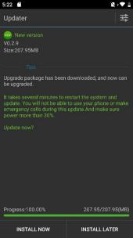

Figure 8- 12 Update Immediately

When the power level is below 30%, the following message will appear and the update cannot be performed.



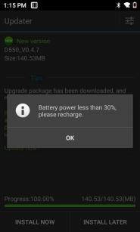

Figure 8- 13 Low Power Handling

4. System update settings,as shown in below figure:

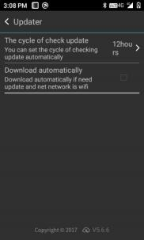

Figure 8- 14 System Update Settings

**8.3** **Mobile** **Butler**

This product is designed to enable customers to set permissions on the Android handheld terminal and disallow the use of unspecified applications.

• Find this icon Settings --> Applications, click on the upper right corner



settings button, Home Application --> select Mobile Butler, press home button to exit and enter the Mobile Butler launcher interface.



Figure 8- 15 Default Launcher

• Administrator Settings and Change Password

(1) In the Mobile Butler interface, tap  menu button to add desktop items.

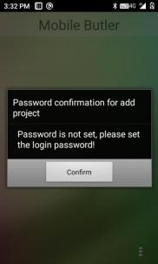

Figure 8- 16 No Password Interface

As shown in the above, the administrator password has to be set first if not already. Tap [OK] button to jump to the change password interface, as below:





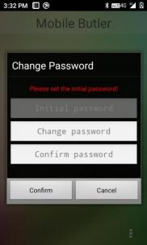

Figure 8- 17 Initial Password Setting

Set the initial password for administrator as required, such as: 123456, then tap Confirm button to successfully set the password. Note: The password cannot be empty and the passwords in new password column and in confirm password column must be the same.

the menu button again, as follows:

(2) Tap

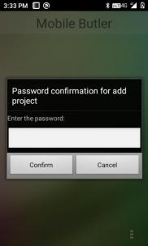

Figure 8- 18 Password Entry Interface



Enter the appropriate administrator password. Once verified, the following will

appear:

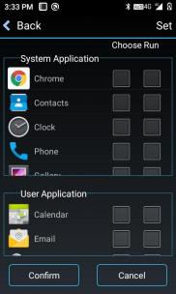

Figure 8- 19 Add Applications Interface

Select apps to add to [ Desktop] and tap [Confirm] to complete the addition. Select an app in [Autostart] column, then the app will auto start after the device reboot (Note: currently autostart only supports one app), as shown below:

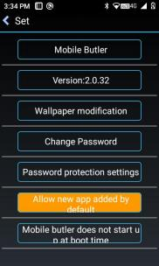

Figure 8-20 Main Interface

(3) Administrator, Change Password

In the Add Applications interface, click [Settings] in the upper right corner to



enter the settings interface, click [Change Password] to show the change password

screen.

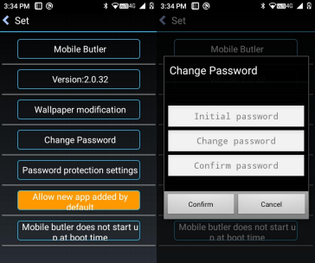

Figure 8-21 Change Password

(4) Administrator, Change Name

Enter [Settings], tap [ Mobile Butler] to change the name of "Mobile Butler".



Figure 8-22 Change Name

(5) Replace Wallpaper

Enter [Settings], tap [Change Wallpaper] to show the below:



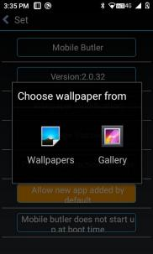

Figure 8-23 Change Wallpaper

(6) Security Settings

Set password security question (selective settings), as shown below:

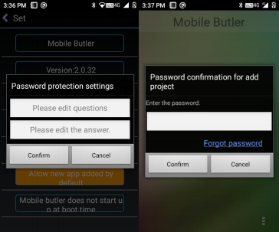

Figure 8-24 Security Settings

As shown in the left picture above, when the security setting is completed, the corresponding option "Forget Password" will be shown in the location where password is required (as shown in the right picture above), which allows to reset the password, otherwise you cannot retrieve the password.



(7) Add new apps by default <--->Not add new apps by default

Select [Add new apps by default], then all apps installed after switching to Mobile Butler will be shown on Mobile Butler desktop; if select [ Do not add new apps by default], then new apps installed will not be shown on desktop.

Note: Applications that are updated online are not "new apps".

(8) Display menu button on desktop <---> Not display menu button on desktop

Control whether the desktop displays the menu button or not, when select [ Display menu button on desktop], the button is displayed on the desktop, tapping the button will show options: Settings/ Exit, as shown:

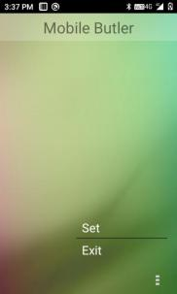

Figure 8-25 Menu Button

Settings: enter the Mobile Butler settings interface directly (password verification required).

Exit: exit Mobile Butler and go back to the default launcher at the very beginning of the system, (by default, the device has a default launcher option when you first enter Mobile Butler).

(9) Mobile Butler Autostart ON <---> Mobile Butler Autostart OFF

Control whether Mobile Butler is used as the default launcher. [ Mobile Butler



Autostart ON] : set the original system launcher as default launcher. [ Mobile Butler Autostart OFF] : set Mobile Butler as default launcher.

**8.4** **Quick** **Configuration**

This application is designed to quickly copy configuration from one device to another of the same model so that the configuration associated with the two devices is identical.

The import of configuration is not possible between different models.

Find this icon  to access the Quick Configuration screen.

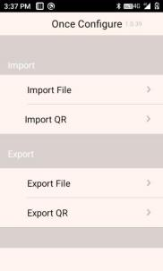

Figure 8-26 Quick Configuration Main Interface

**8.4.1** **Import**

1. File Import

Put the eligible configuration zip file in the specified directory of the external SD card to achieve configuration. The external SD card system path is: external SD



card/SysSetting/Setinfo.tar.gz.

(1) Manual Import :

1) Put the configuration zip package (file name is Setinfo.tar.gz) into the external SD card/SysSetting directory, as shown below:

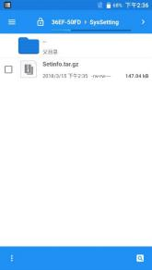

Figure 8-27 Configuring Zip Directory

2) Enter Quick Configuration, click [ File Import], and the following prompt pops up, tap [Confirm].

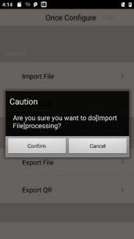

Figure 8-28 File Import



(3) After successful import, the imported items and status will pop up, tap to confirm, then a restart prompt will pop up, tap [ Restart Now] to complete (some configurations will not take effect immediately without restart).

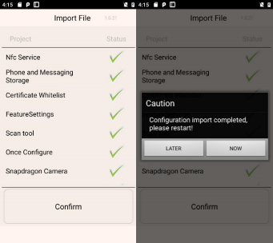

Figure 8-29 File Configuration Import Success

1. QR Code Import

This function can be used to import external configuration files by scanning QR codes, and can call the camera to scan external QR codes to import configuration files.

(1) Enter Quick Configuration, tap [QR code Import], place the QR code to be imported in the scan box, as shown below:

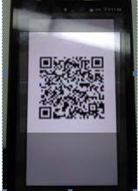

Figure 8-30 QR Code Import Screen



(2) After successful scanning and transmission, the imported items and status of the QR code will pop up, click to confirm, then a restart prompt will pop up, tap [ Restart Now] to complete (some configurations will not take effect immediately without restart).

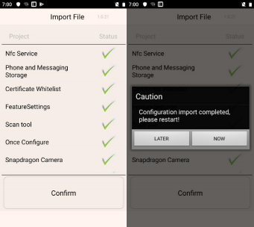

Figure 8-31 QR Code Import Success

8.4.2 Export

1. File Export

This function can export all the configuration items in the configuration import and export tool to the specified directory of the built-in SD card or external SD card of the device. The name of the export file is Setinfo.tar.gz. The path of the export file is: a) external SD card/SysSetting/

b) Built-in SD card/SysSetting/

Where the device has an external SD card, file exports are preferred to be on external SD card.

(1) Enter the Quick Configuration, tap [ File Export], the following interface pops up to indicate that the export was successful, where the external SD card already has a configuration document, the export will prompt notification to



overwrite the original.

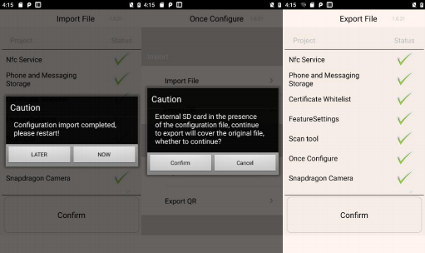

Figure 8-33 File Export

(2) The exported file name is Setinfo.tar.gz, enter [ File Manager] ---> [ Phone Storage] ---> [ External SD Card] ---> [SysSetting] to view:

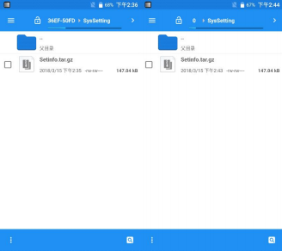

Figure 8-33 File Export Path

2. QR Code Export

This function exports a QC code which can be scanned by another device to establish a Bluetooth channel to transfer the configuration file.

(1) Enter Quick Configuration, tap [ File Export] and the following interface will



pop up to indicate that the export was successful, thentap to confirm:

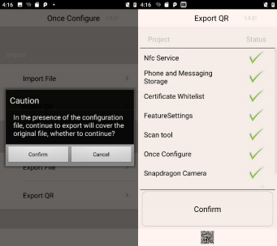

Figure 8-34 QR Code Export

(2) The generated QR code image is at the bottom of the application and can be viewed by clicking on the small QR code icon.

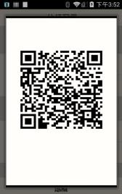

Figure 8-35 QR Code Image

8.4.3 User Configuration

1. User Configuration File

Name: UserConfig.xml

Storage location: a) External SD card/SysSetting/ UserConfig.xml



b) Built-in SD card/SysSetting/ UserConfig.xml

Note: When exporting the config file, the external SD card is preferred.

Example:

<?xmlversion="1.0" encoding="UTF-8"?>

<projects>

<projectdesc="MobileBulter" desc_zh="移动管家">

<path>/data/data/com.cn.seuic.homedemo/databases/homeApp.db3</path> <path>/data/data/com.cn.seuic.homedemo/files/wallpaper.png</path> </project>

<project desc="WIFI information" desc_zh="WIFI 信息">

<path>/data/misc/wifi/wpa_supplicant.conf</path>

</project>

</projects>

des: default name of the config item

des_zh : Chinese name of the config item

Path: path of config items (can be multiple, e.g. Mobile Butler)

Note: If other languages are available, add the corresponding name in format of: des_standard-language-abbreviation = corresponding language config name.

2. Export User Configuration File

Place the user config file that meets the document requirements in the specified location as shown below (for example, place on an external SD card):

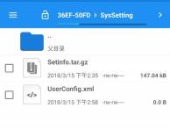

Figure 8-36 User Configuration File

Enter the Quick Configuration and tap [ File Export], the following interface appears,

which means the export is successful :



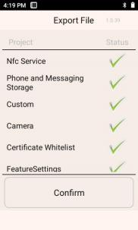

Figure 8-37 User Configuration Files Export Success

**8.5** **Feature** **Key** **Settings**

This application is used for quick and easy implementation of customer specific needs.

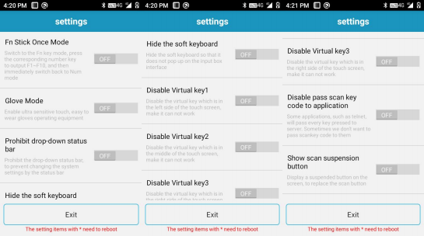





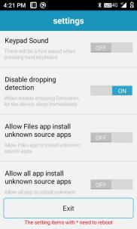

Figure 8-38 Feature Key Settings

**8.5.1** **Fn** **Sticky** **Keys**

When switching to Fn key mode, press the corresponding numeric key to output F1~F10 once, and the system then immediately switches back to Num mode.

**8.5.2** **Block** **P5** **Function** **Key**

If enabled, the P5 key function is disabled.

**8.5.3** **Block** **P7** **Function** **Key**

If enabled, the P7 key function is disabled.

**8.5.4** **Touchscreen** **Glove** **Mode**

If enabled, support touchscreen operation with gloves, where the touchscreen is more sensitive.



**8.5.5** **Disable** **Status** **Bar** **Dropdown**

If enabled: effective immediately where the dropdown menu is not available.

If disabled : effective immediately where the dropdown menu functions normally.

**8.5.6** **Prohibit** **Passing** **Scan** **Key** **Value** **to** **Apps**

If enabled: some applications such as Telnet will send all keys pressed to the

server.

If disabled : in some cases, forbid applications such as Telnet to pass all the keys pressed to the server.

**8.5.7** **Show** **Scan** **Float** **Button**

If enabled: shows a float button on screen which allows to trigger scan via touchscreen.

If disabled : no float button on screen, and scan can only be triggered by pressing physical scan keys.

**8.5.8** **Hardware** **Keyboard** **Tones**

If enabled: there are corresponding tones when using the physical keyboard.

If disabled : there are NO corresponding tones when using the physical keyboard.

**8.5.9** **Prohibit** **Fall** **Detection**

If enabled: the system will not go to sleep when the device is dropped.

If disabled : the system will immediately go to sleep when the device is dropped.

**8.6** **Digital** **Certificates** **Whitelist**

This software is used to add specific digital certificates to the whitelist.



Applications that are signed by digital certificates from the whitelist can be directly installed without enabling the “Install from Unknown Source” in system settings. The application password is: 4007770876.

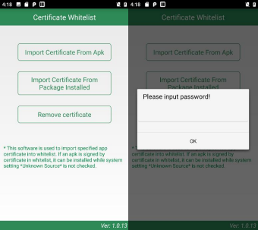

Figure 8-39 Digital Certificates Whitelist

1. Import certificates from APK files

The application will search for all APK files in the internal storage device directories and display their file names and located directories. The user can import the certificates from the selected APK files into the system by tapping the [ Import] button after checking single or multiple display items.



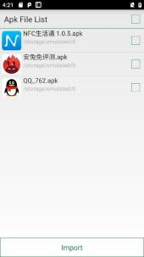

Figure 8-40 APK File Import List

2.Import certificate from installed packages

The application will display the names of third-party apps installed in the system and their package names, and the user can import the certificates from the selected APK files into the system by tapping the [ Import] button after checking single or multiple display items.

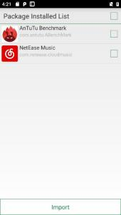

Figure 8-41 Installed Package List

3. Remove Certificates from Whitelist



The application will display the names of added certificates. Tap [ Remove] to remove the certificates from the system whitelist after checking single or multiple display items. Those displayed in gray without a checkbox are system default certificates that cannot be deleted.

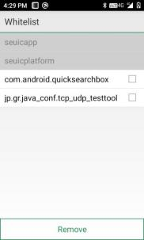

Figure 8-42 Signature Whitelist Categories

Cautions:

The added certificate will be named after the app package name.

For certificates with the same content but different package names, only one record is saved, and it is named after the first record.

**8.7** **Hotkey** **Settings**

This application is used for shortcut key (Fn) settings, which allows customers to quickly use frequently used applications.

1. Find this icon  and enter [ Hotkey Settings] interface.

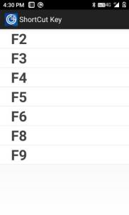

Figure 8-43 Hotkey Settings Main Interface

2. Hotkey settings, tap the Fn key (e.g., F2) to enter the settings interface, as shown below:

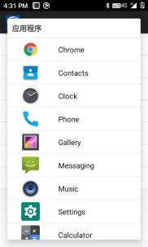

Figure 8-44 Adding Hotkeys Interface

Simply select the appropriate application, as shown below:



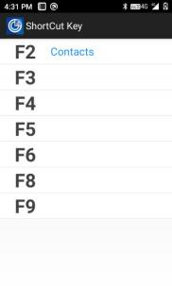

Figure 8-45 Hotkey Settings Success Interface

3. To unbind a hotkey, press and hold the Fn key (e.g., F2) to bring up the following screen:

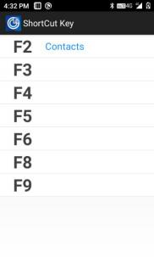

Figure 8-46 Unbind hotkey

Tap [ Unbind] to cancel the hotkey; Tap [Cancel] to exit the hotkey unbind screen.

4. To use hotkeys, switch the keys on the device to FN mode, the taskbar at the top of the screen will show the FN mode, and then press the keyboard F1- F9. But for



P1-P7 shortcut keys, no need to switch to Fn mode.





**Chapter** **9.** **Troubleshooting**

|  |  |  |  |
| --- | --- | --- | --- |
| **Issue** | | **Cause** | **Solution** |
| AUTIOD Q9 does not power up after pressing the power button. | | Low battery or uncharged battery. | Charge or replace the battery. |
| Incorrect battery installation. | Install the battery  correctly. |
| System crash. | Perform a soft reboot. |
| Rechargeable battery no longer charges. | | Battery malfunction. | Replace the battery. |
| Battery temperature too high/low. | Keep the battery at room temperature. |
| No sound. | | Volume set too low or turned off. | Adjust the volume. |
| AUTIOD Q9 auto turns off. | | AUTIOD Q9 is inactive. | After a period of inactivity, the mobile data terminal will turn off. This period can be set to 15s to 30min or never sleep |
| Battery is drained. | Charge or replace the battery |
| AUTIOD Q9 fails to decode when reading a barcode. | | Scanner program is not opened | Load the scanner program in AUTIOD Q9 |
| Currently in barcode settings or application settings  screen. | Set the scanner to the scan screen or hide the  scanner. |
| Unreadable barcode. | Ensure that the barcode is not defective. |
| Barcode decoding function is not enabled. | Enter barcode settings, open corresponding decoding. |
| AUTIOD Q9 does not support this barcode type decoding. |  |
| The distance between the AUTIOD Q9 and the barcode is not appropriate. | Place the AUTIOD Q9 in the correct scanning  range. |
| Cannot find Bluetooth nearby. | any  device | Too far from other Bluetooth devices. | Move the device closer to other Bluetooth devices, within 10 meters (32.8 feet) of each other |
| Bluetooth is not enabled on the nearby device. | Turn on the Bluetooth of the device you are looking for. |



|  |  |  |  |  |
| --- | --- | --- | --- | --- |
|  | Bluetooth device is not in discoverable mode. | | | Set Bluetooth device to discoverable mode. |
| Unable to connect to AP. | Displays  failure". | "authentication | | The WLAN password is incorrect. |
| Unable to take a picture. | Prompts "No storage  device". | | | Exit USB storage mode. |
| Prompts malfunction". | | "camera | Turn off 2D scanningwhich blocks camera usage. |
| Prompts "Not enough space on SD card". | | | Free up storage or switch storage location. |
| Unable to access the Internet using mobile data. | Mobile data is not turned  on. | | | Go to Settings and enable mobile data. |
| Incorrect network mode selection, and SIM card is not registered. | | | Go to Settings and select the correct network mode. |
| SIM card payment default. | | | Timely top up SIM card. |



**Optional** **Accessories**

Please keep the original box and packaging for future maintenance or storage of the device. The following accessories can better enhance your work and can be purchased if needed.

入 One AUTIOD Q9 Series Device

入 One USB Cable (standard)

入 One Hand Strap (standard)

入 Device Protect Cover (optional)

入 Device Single Charging Dock (includes battery charging) (optional)

入 Device Tetra Charging Dock (optional)

入 Battery Tetra Charging Dock (optional)

入 Grip (optional)

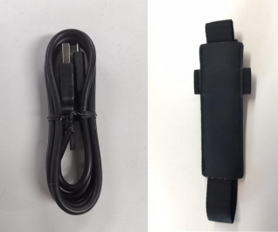

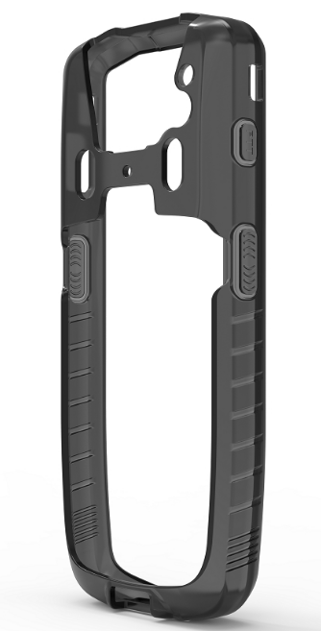



**Device** **Single** **Charging** **Dock**

|  |  |
| --- | --- |
| **Rated** **Input** **Voltage** | DC 4.75~5.5V |
| **Rated** **Input** **Current** | DC 5A (MAX) |
| **Rated** **Output** **Voltage** | DC 4.75~5.5V (charging for the whole device)  DC 4.40V±0.05V (charging for the battery) |
| **Rated** **Output** **Current** | DC 2A MAX (charging for the whole device)  DC 2A MAX (charging for the battery) |
| **LED** **Indicators** | Power status indicator (red light: power adapter)  Battery charging indicator (red light: charging in progress; green light: charging complete) |

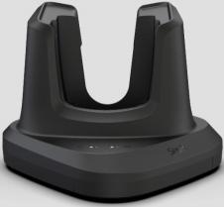

**Device** **Tetra** **Charging** **Dock**

|  |  |
| --- | --- |
| **Rated** **Input** **Voltage** | DC 12± 1V |
| **Rated** **Input** **Current** | DC 5A (MAX) |
| **Rated** **Output** **Voltage** | DC 5.2±0.5V |
| **Rated** **Output** **Current** | DC 2A*4(TYP) |
| **LED** **Indicators** | Power status indicator (red light when connected to power adapter) |

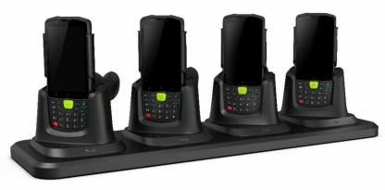

Device Tetra Charging Dock (Grip is optional)



**Battery** **Tetra** **Charging** **Dock**

|  |  |
| --- | --- |
| **Rated** **Input** **Voltage** | DC 12± 1V |
| **Rated** **Input** **Current** | DC 5A (MAX) |
| **Rated** **Output** **Voltage** | DC 4 4± 2% V * 4 |
| **Rated** **Output** **Current** | DC 2A*4(MAX) |
| **LED** **Indicators** | Power status indicator (green light: power adapter)  Battery charging indicator *4 (red light: charging in progress; green light: charging complete) |

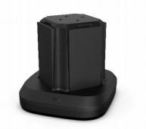

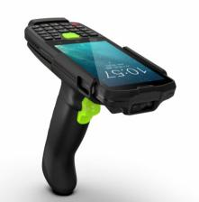

Device + Grip

## Device Single Charging Dock(BC03)

|  |  |
| --- | --- |
| **Rated Input Voltage** | DC 8.75~9.25V |
| **Rated Output Current** | DC 3A (MAX) |
| **Rated Output Voltage** | DC 4.75~5.5V（charging for the whole device）  DC 4.40V±0.05V（charging for the battery） |
| **Rated Output Current** | DC 2A MAX（charging for the whole device）  DC 2A MAX（charging for the battery） |
| **LED Indicators** | Power status indicator (red light: power adapter)  Battery charging indicator (red light: charging in progress; green light: charging complete) |

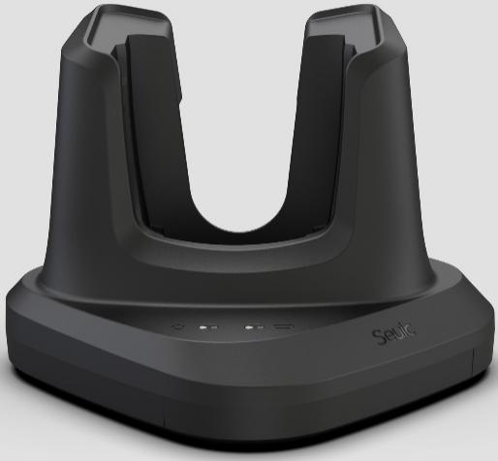

## Battery Tetra Charging Bock (BC03)

|  |  |
| --- | --- |
| **Rated Input Voltage** | DC 8.75~9.25V |
| **Rated Output Current** | DC 3A (MAX) |
| **Rated Input Voltage** | DC 4.4±2% V * 4 |
| **Rated Output Current** | DC 1.6A*4(MAX) |
| **LED Indicators** | Power status indicator (green light: power adapter)  Battery charging indicator *4 (red light: charging in progress; green light: charging complete) |

