

AUTOID®Q9 Series Single Seat Charger
Product Specification V0.1

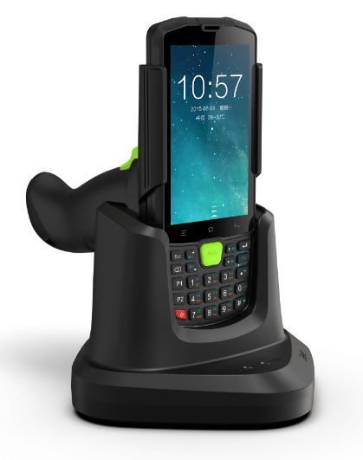

SEUIC Technologies Co., Ltd.

I. Physical Parameters and Environment Parameters
Rated input voltage | DC 4.75-5.5V
Rated input current | DC 5A (MAX)
Rated output voltage | DC 4.75-5.5V (power supply of the complete machine);  DC 4.40V ± 0.05V (battery charging)
Rated output current | DC 2A MAX (power supply of the complete machine);  DC 2A MAX (battery charging)
LED indicator | Power status indication (red light: power adapter)  Battery charging indicator (red light: charging; green light: charging completed)  RJ45 status indicator (green: connection indicator; yellow: data indicator)
Data interface | DC interface; TYPE-C; RJ45
Operating temperature | -20 ℃ ~ + 55 ℃ (data communication);  0 ℃ ~ 55 ℃ (battery charging)
Operating humidity | ＜90%RH
Storage temperature | -20℃~ +70℃
Storage humidity | ＜95%RH
Cooling mode | Natural convection
IP protection | IP30
Reliability | 1m drop to cement floor
Spring pin connector | On resistance < 100mΩ
Antistatic level | Contact electrostatic test ≤ 8KV
Safety specification standard | GB60950 UL1950 GB4943
DC interface insertion and extraction force | ≥0.3KGF
Weight | ＜258g
Overall dimension | 160*115*111mm (L*W*H)
Standard accessories | 5V 5A adapter × 1, packing materials

II. Operating Instructions and Schematic Diagram
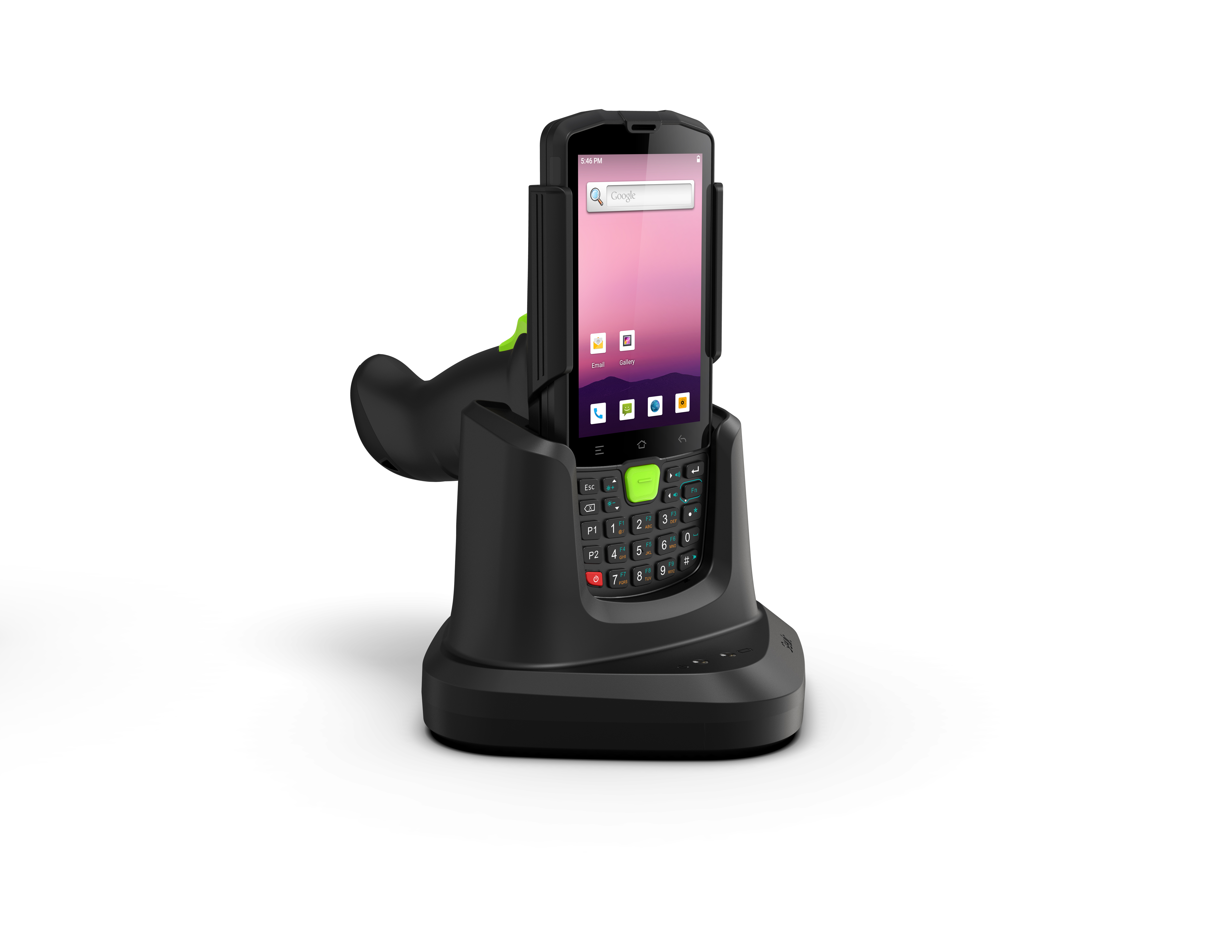

Figure 1: Structural diagram

- Instructions for charging battery
- Fix the battery in the battery card slot of the single seat charger;
- Using AC power, insert the AC plug of the supporting power adapter into the standard socket and make it contact well;
- Use the supporting DC charging line to reliably connect the DC head of the power adapter with the single seat charger;
- Status indication of battery charging indicator: ① Not on without the battery; ② Charging: red; ③ Fully charged: green; ④ Fault: red and green flashing alternately;
- During charging, it is normal for the battery and the single seat charger to have slight heating.

2. Instructions for charging complete machine
1) Place the PDA on the single seat charger (as shown in Figure 1);
2) Using AC power, insert the AC plug of the supporting power adapter into the standard socket and make it contact well;
3) Use the supporting DC charging line to reliably connect the DC head of the power adapter with the single seat charger;
4) The color of the power indicator is red, which is only used as an indication of whether the single seat charger is powered on, that is, the red indicator will be on after the external power adapter is connected;
6) During charging, it is normal for PDA and single seat charger to have slight heating;
7) The PDA charging status is subject to the PDA charging indicator, that is, the red indicator indicates it is being charged, and the green indicator indicates it is fully charged.

III. Notes
- Before using this equipment, please read the operating instructions and product surface identification carefully.
- Please use the battery in a normal indoor environment. Temperature: 0 ~ 55 ℃, relative temperature: ＜ 90% RH;
- During use, keep away from heat source and high voltage, avoid children playing with the equipment, and do not beat the charging base;
- Please keep the connector clean. Do not let other metal objects directly contact the connector of the charging base during use, otherwise the product may be damaged due to danger or short circuit;
- Do not throw and impact the equipment or use it in a strong vibration environment, otherwise the charging effect will be damaged or affected;
- This equipment can only be charged with the supporting power adapter;
- In case of failure, please consult your local dealer or our customer service center.

