

AUTOID®Q9 Series Quadruple Seat Charger of Complete Machine

Product Specification V0.1

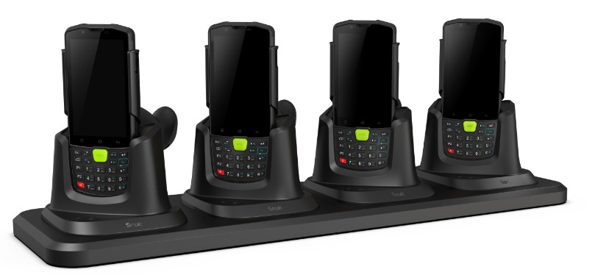

SEUIC Technologies Co., Ltd.
I. Physical Parameters and Environment Parameters
Rated input voltage | DC 12±1V
Rated input current | DC 5A (MAX)
Rated output voltage | DC 5.2±0.5V
Rated output current | DC 2A*4(TYP)
LED indicator | Power status indication (the red indicator will be on when connecting the power adapter)
Operating temperature | -10℃~ +50℃
Operating humidity | ＜90%RH
Storage temperature | -20℃~ +60℃
Storage humidity | ＜95%RH
Cooling mode | Natural convection
IP protection | IP30
Reliability | 0.5m drop to cement floor
Spring pin connector | On resistance < 100mΩ
Antistatic level | Electrostatic contact test < 8KV
Weight (four continuous charging) | < 1,100g (to be confirmed)
Overall dimension | 402mm × 184mm × 106mm (to be confirmed)
Standard accessories | Adapter × 1, charging line × 1, packing materials

II. Operating Instructions and Schematic Diagram

Figure 1: Schematic diagram of placement method

1. Place the PDA on the quadruple seat charger of the complete machine (as shown in Figure 1);
2. Using AC power supply, insert the AC plug of the supporting power adapter into the standard socket and make it contact well; Connect the DC connector to the charging base at the other end;
3. The color of the power indicator is red, which is only used as an indication of whether the quadruple seat charger of the complete machine is powered on, that is, the red indicator will be on after the external power adapter is powered on;
4. During charging, it is normal for the machine and the charging base to have slight heating. Please rest assured to use it;
5. The PDA charging status is subject to the PDA charging indicator, that is, red indicates it is being charged and green indicates it is fully charged.

III. Notes
- Before using the equipment, please carefully read the operating instructions and product surface identification;
- Please use the battery in a normal indoor environment. Temperature: 0 ℃ ~ + 50 ℃, relative humidity: ＜ 90% RH;
- During use, keep away from heat source and high voltage, avoid children playing with the equipment, and do not beat the charger;
- Please keep the spring pin connector clean. Do not let other metal objects directly contact the spring pin connector of the charger during use, otherwise it may cause danger or short circuit and damage the product;
- Do not throw and impact the equipment or use it in a strong vibration environment, otherwise the charging effect will be damaged or affected;
- This equipment can only be charged with the supporting power adapter;
- This equipment has no components that can be repaired at will. In case of failure, please consult your local dealer or our customer service center.

