Grinding needle stone industrial browser instructions
modifier | Michael_ray
Modify time | 2022.12.28
modified versions | V2.4.9
VersionInfo | V2.4.9：1、Solve the login authentication problem2、Solve the problem of automatic page enlargement after fixed zoom 3、Modify the app and home page icon 4、Add automatic adaptive pages 5、Auto scaling is turned off by default
V2.4.8 | Associated Development Review Single System Special - Enterprise Browser optimization requirements

Directory
Grinding needle stone industrial browser instructions 1
Directory 2
1、Activation and trial 3
2、Connection 5
1. Enter the link you want to jump to in the link input box in the diagram, Click Connect to enter 5
3、Favorites 6
4、Whitelist 8
5、Web menu function 10
（1）Go back to the previous page 10
（2）Favorites 10
（3）Add favorites 11
（4）Manage favorites 12
（5）History 13
（6）refresh the page 13
（7）Set brightness level to automatic 13
（8）clear cache 14
（9）Zoom setting 14
（10）Fix the screen horizontally 15
（11）Open a new TAB 16
（12）Switch tag 17

1、Activation and trial
（1）The relevant functions of industrial browsers need to be activated, Devices that are not activated have a trial period of 30 days. Devices that exceed the trial period can be used only after being activated.
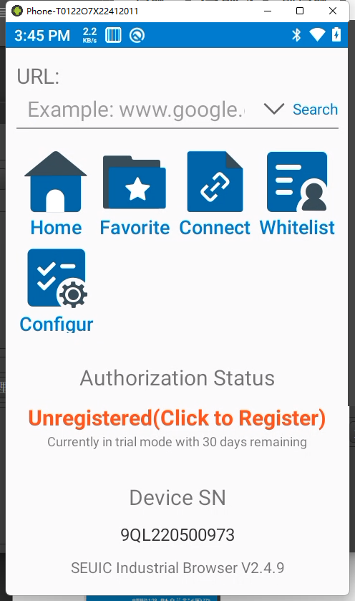
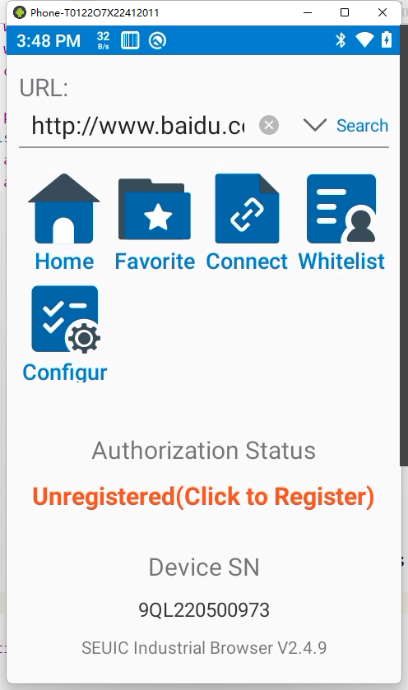

试用中 试用结束
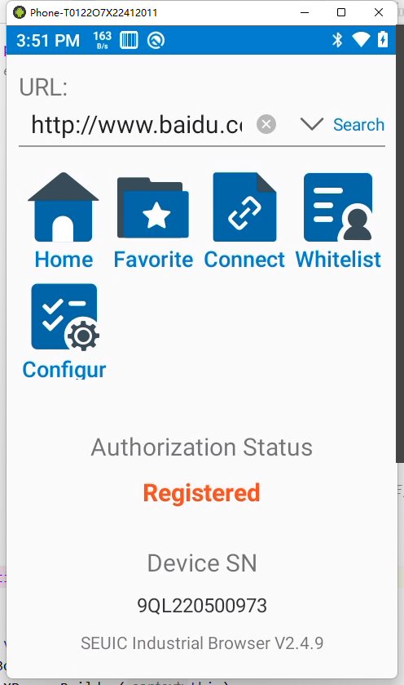

激活成功

- 激活流程
点击图中的红字( 未激活(点击激活) )开启激活流程

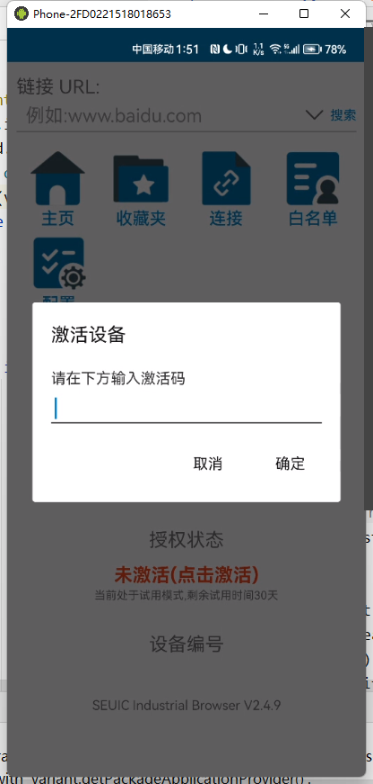

2、Connection
- Enter the link you want to jump to in the link input box in the diagram, Click Connect to enter
If a connection has already been used, Industrial browsers save usage records for you, Click on the right side of the connection input box， ,
The history is displayed, If you don't want to keep the history, can be manually deleted.
If the whitelist has been enabled, the history will be replaced by the whitelist list, the clearing function is not provided, If you want to clear, Please go to the whitelist screen
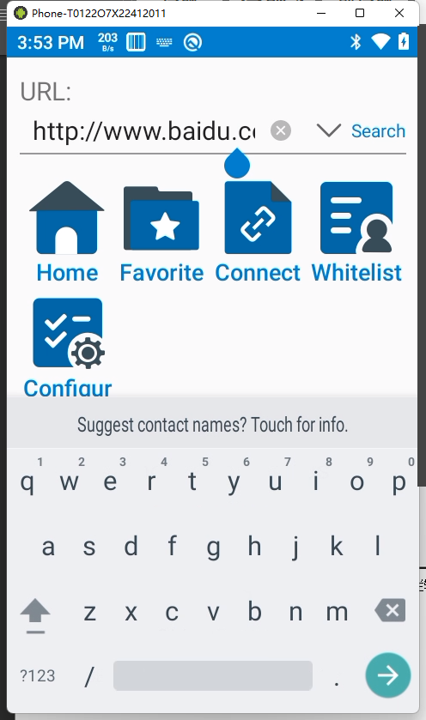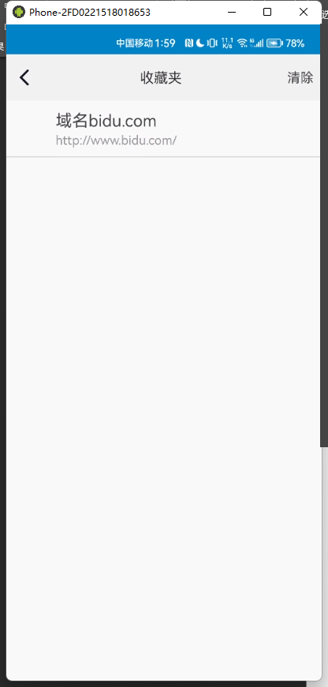
- Added the OK or search click-to-go feature，Add page title bar input search function

3、Favorites
- The Favorites function is used to save a specified interface, convenient quick jump, Click Favorites in Figure 1 or click Favorites in Figure 2 to jump to the interface in Figure 3

- The list in Figure 3 is a collection of Web pages, Contains the icon, page title and URL three parts
Note: In Figure 2, click on Figure 1 ,connect to the jump interface, In Figure 2, Tap the menu button on your phone, the function menu will pop up at the bottom, As shown in Figure 2, the functionality details are explained below

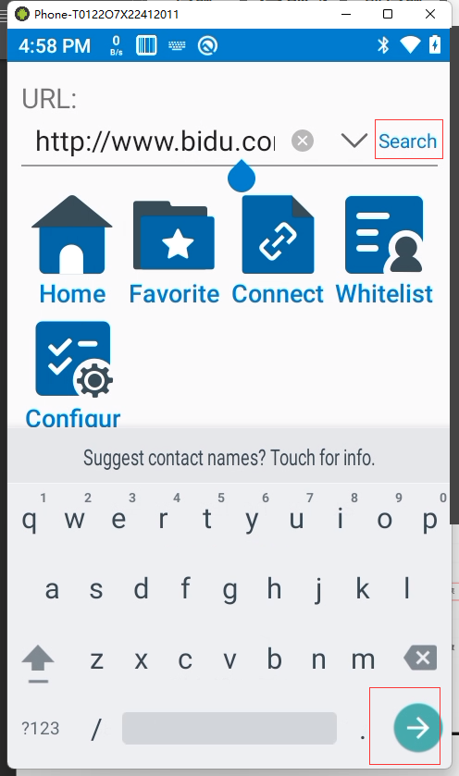
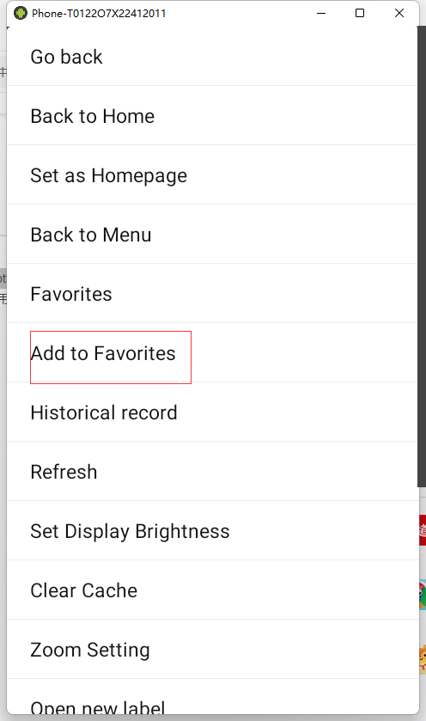

- Clicking on the corresponding favorites will take you to the corresponding webpage, Holding down a favorite triggers the favorites to be whitelisted (The whitelist is used to filter the links that can be skipped, to ensure safety, When the whitelist is enabled, Access to websites that are not in the whitelist is prohibited), whitelist control is described below.

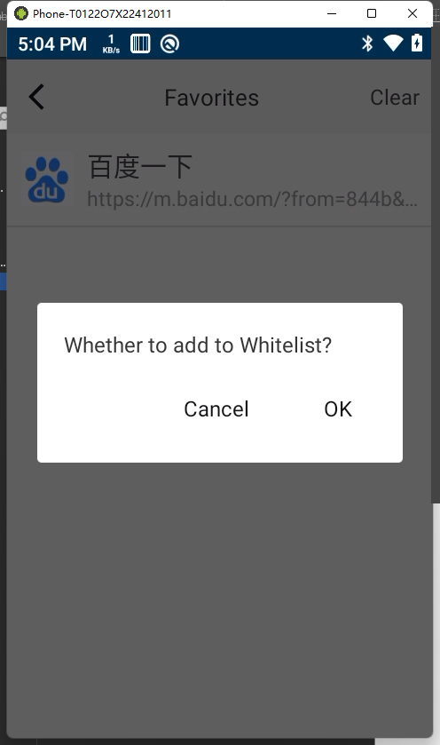

4、Whitelist
- The whitelist is used to filter the links that can be skipped, to ensure safety, When the whitelist is enabled, Access to websites that are not in the whitelist is prohibited, You need to verify the password to access the whitelist page, If no password is set, the Settings are prompted first.
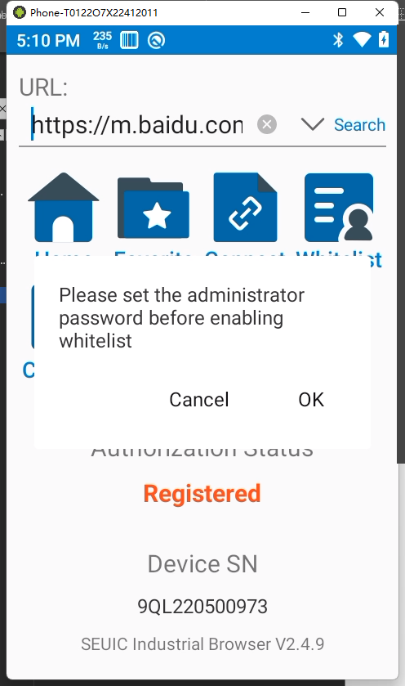
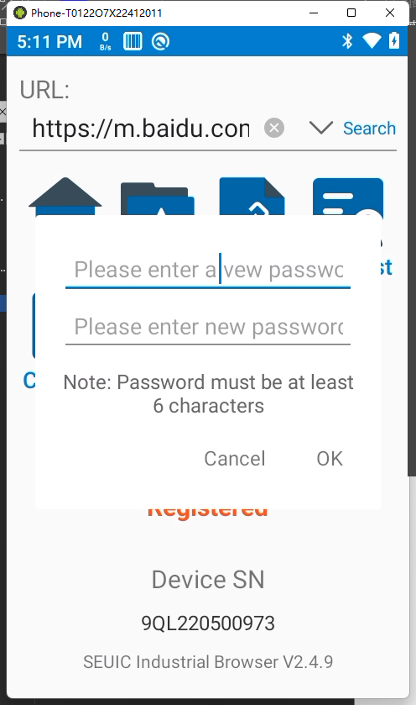

- You can forget the password when entering the whitelist, If you forget the password, you can reset the password by verifying the activation code
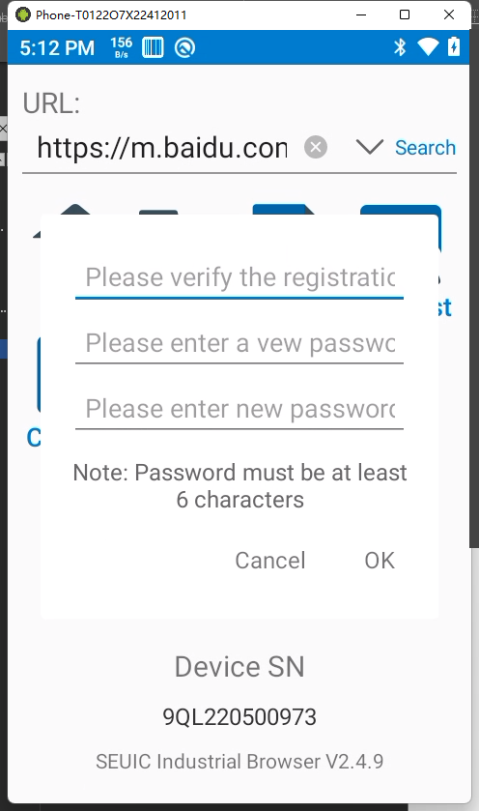

- Whitelist interface
The whitelist is disabled by default. You can enable it manuallyThere are two ways to add a whitelist1. Press and hold the page in your favorites to join,2. Click New in the whitelist Press and hold the whitelist list to editConvenient and quick modification
The password change function is provided in the upper right corner
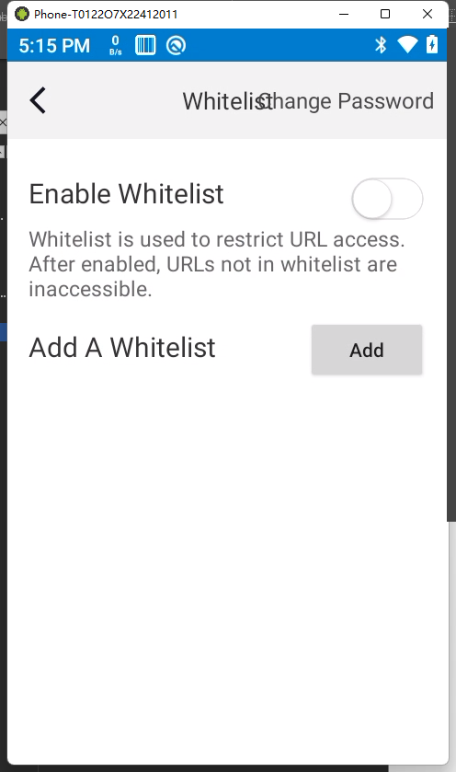
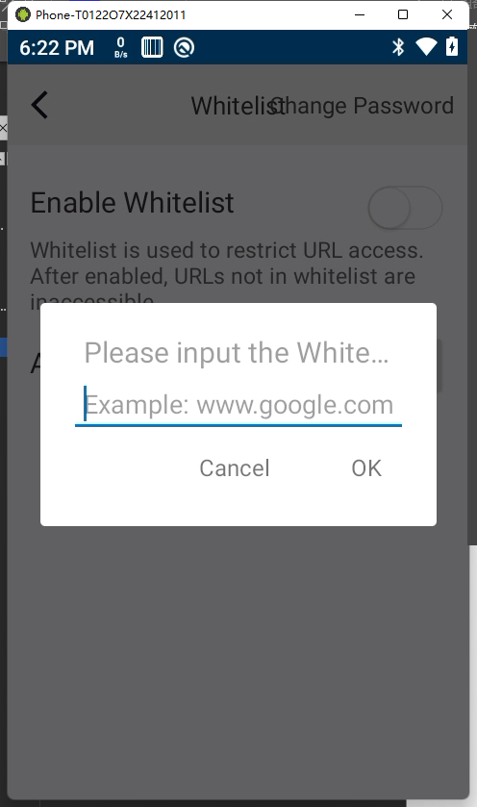

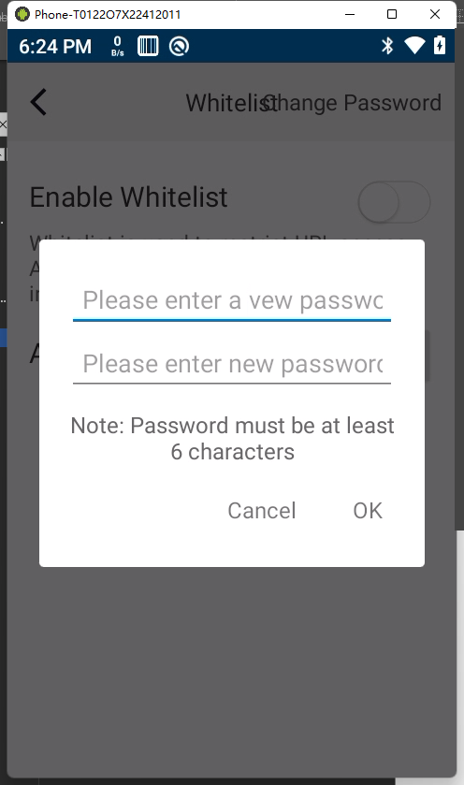

5、Web menu function

（1）Go back to the previous page
Click to return to the main screen, Industrial browsers support mobile phone back key back to the history interface, This feature is for quick returns
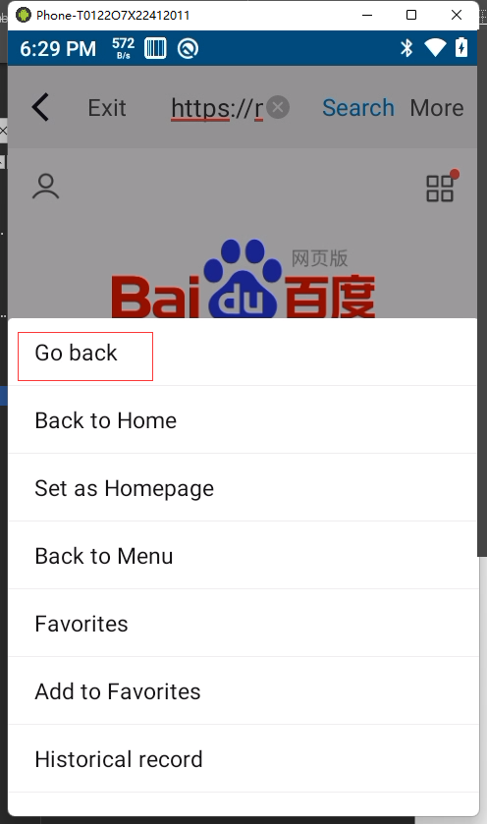

（2）Favorites
The Favorites page is displayed
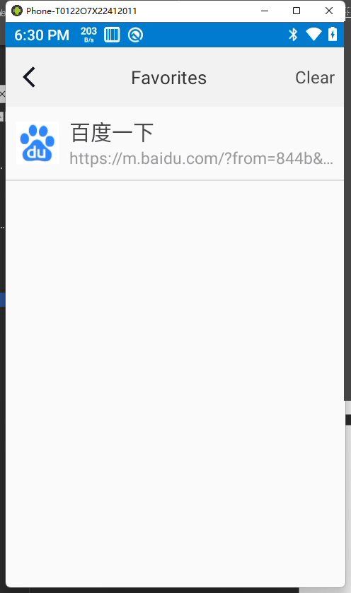

（3）Add favorites
Add web pages to Favorites
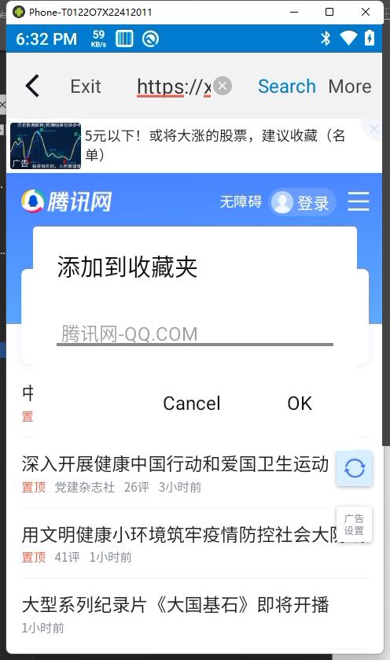

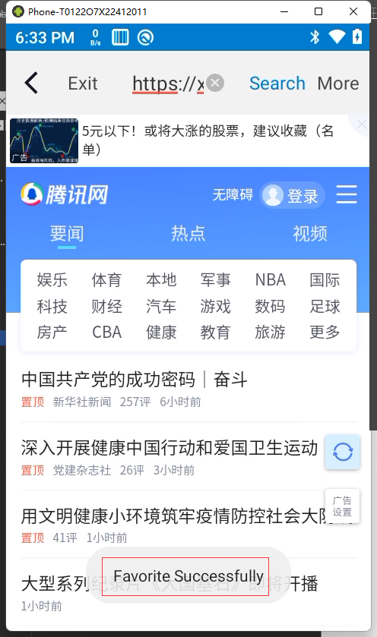

（4）Manage favorites
Click the Clear button in the upper right corner to clear your favorites with one click
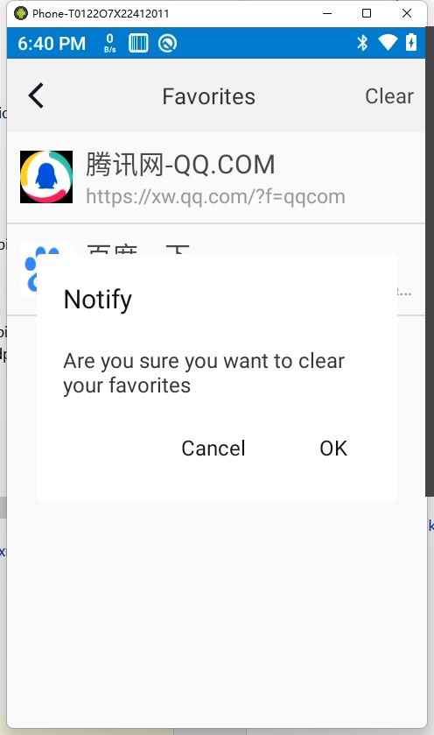

Click on a single favorite item in Favorites to open the Web page
Holding down a single favorite entry in a Favorites folder allows you to whitelist it

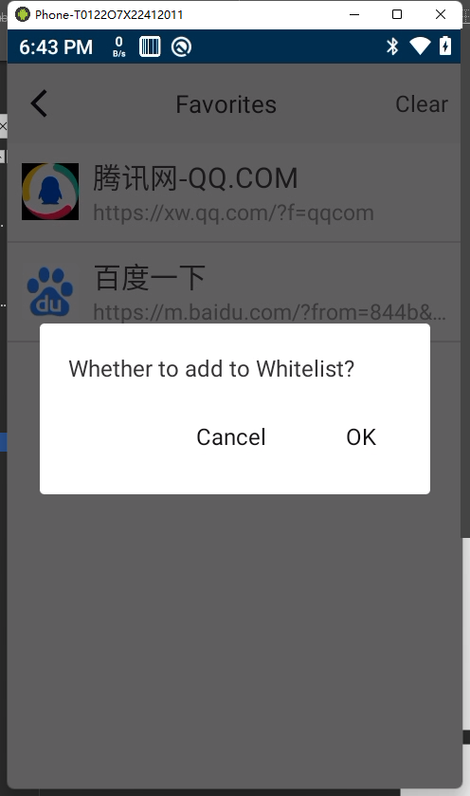

（5）History
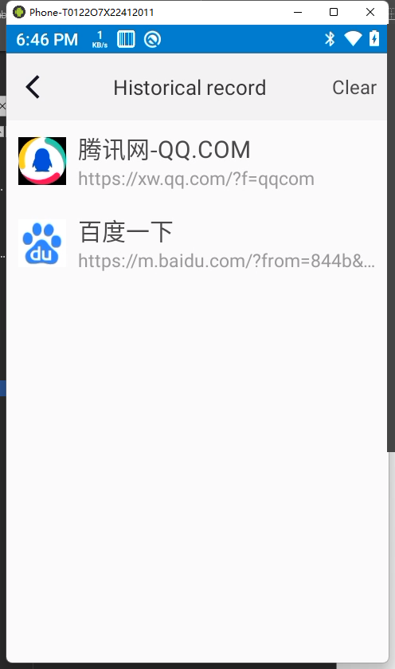
The address title and icon of each link visited by the browser are saved in the history
Click Clear to delete all records

（6）refresh the page
Reload the current web page

（7）Set brightness level to automatic
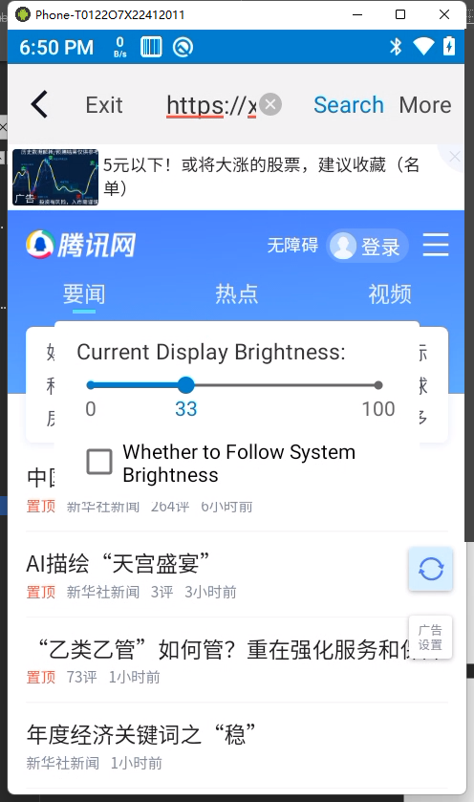
Customize the screen brightness, which follows the system brightness by default

（8）clear cache
Clear the app web cache to clear the historical data information entered, avoid information leakage.

（9）Zoom setting
The zoom setting allows manual adaptation of web pages without mobile interface adaptation,
The Fixed screen option disables the screen from swiping left and right, only up and down, Fixed adaptive interface for easy operation

For the web page that has already done the mobile interface adaptation, Industrial browsers support font enlargement and reduction operations, Without changing the scale of the interface, Control the font size
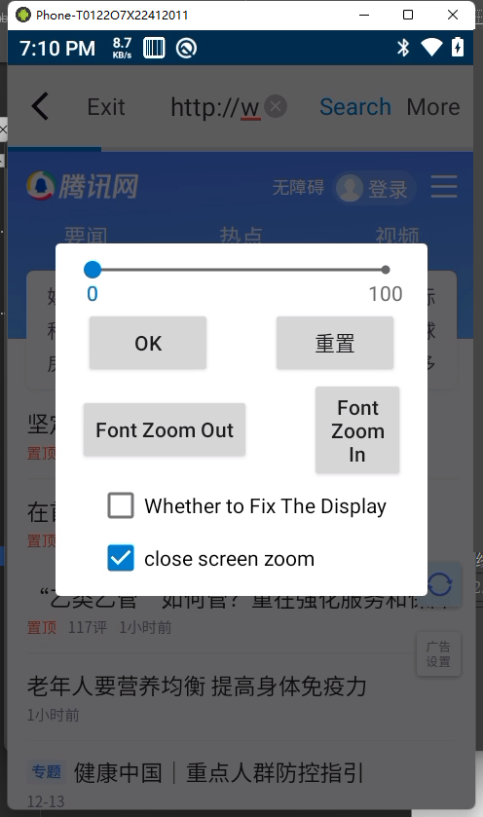

（10）Fix the screen horizontally
Open only allow sliding in the vertical direction，Horizontal sliding is prohibited

（11）Open a new TAB
Open a new window
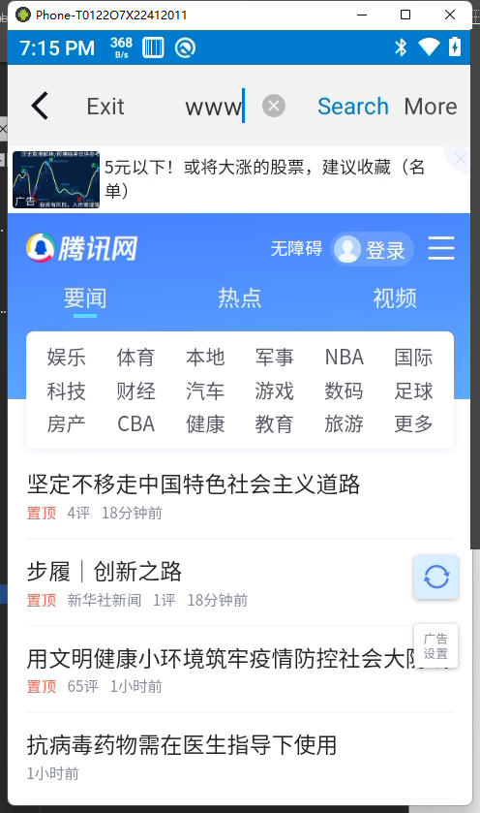

（12）Switch tag
Different Windows multitask Windows run
